**Microsoft DAX Documentation with examples:** [**https://learn.microsoft.com/en-us/dax/**](https://learn.microsoft.com/en-us/dax/)

**1] DAX - Introduction**

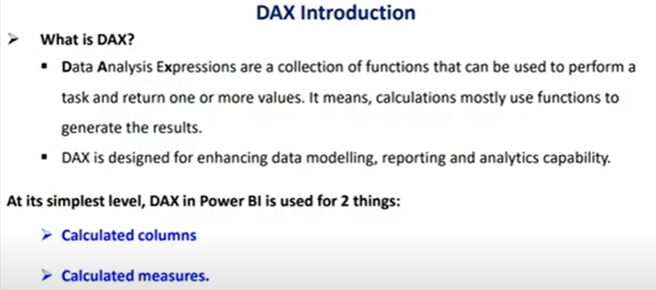

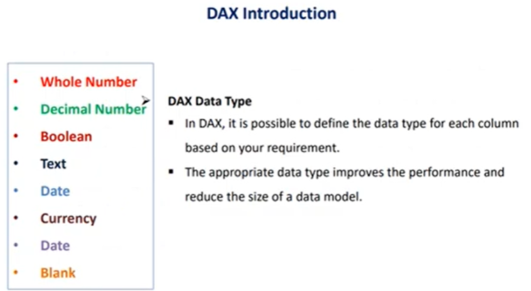

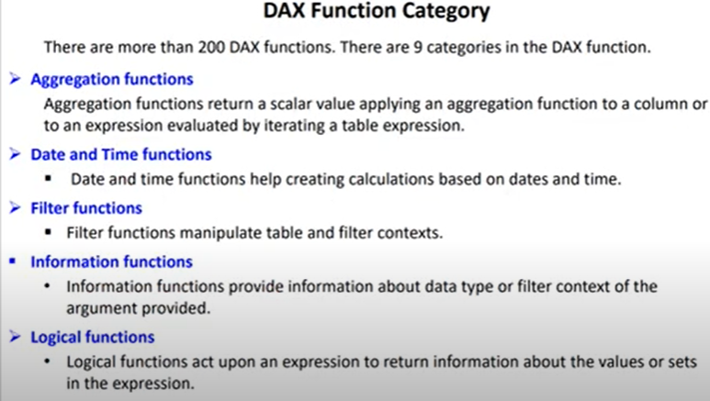

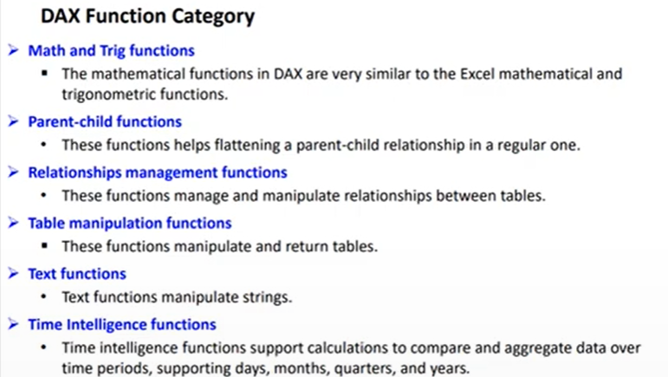

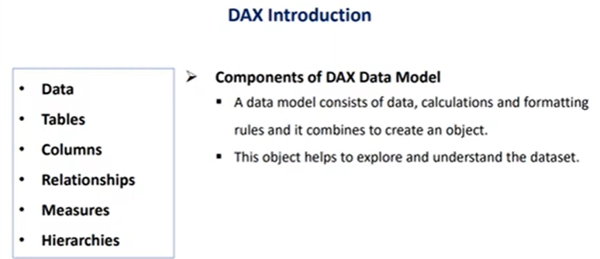

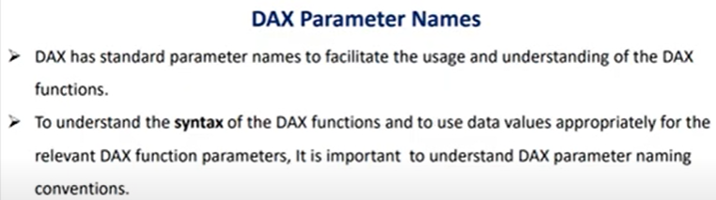

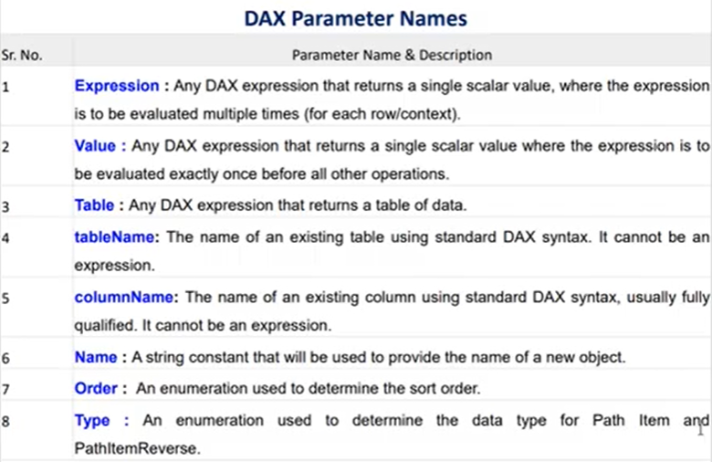

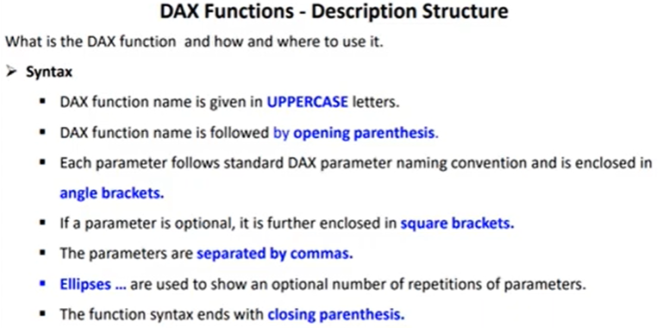

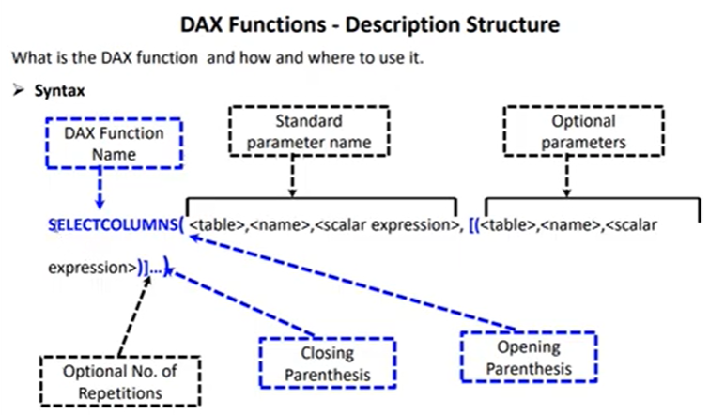

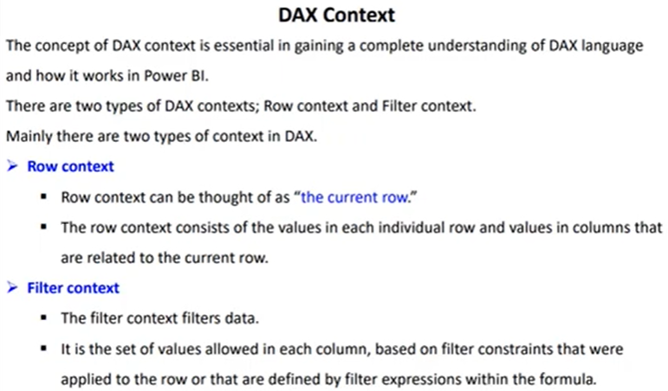

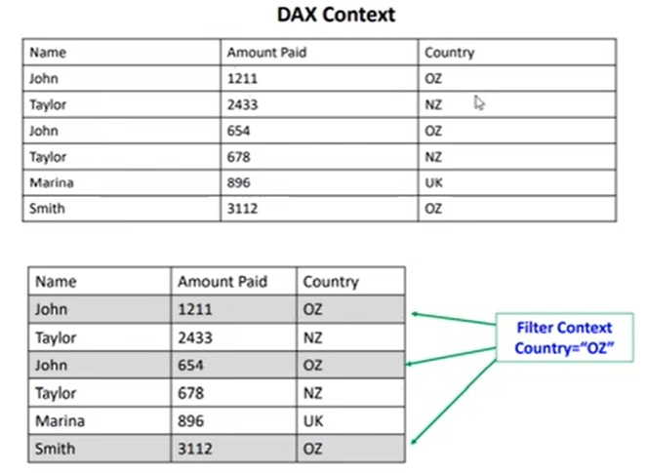

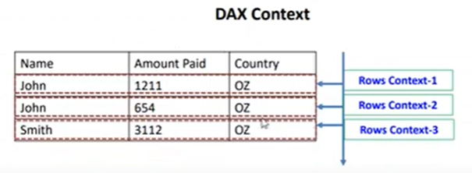

**2] DAX - Calculate Function**

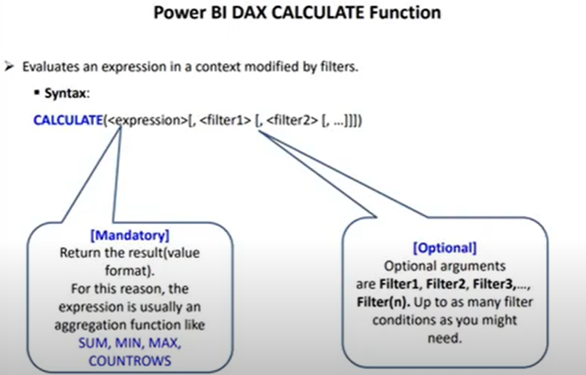



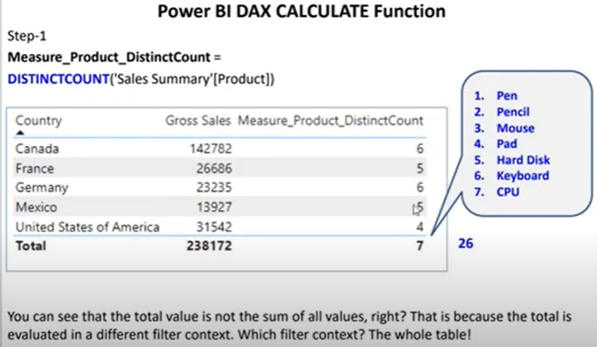

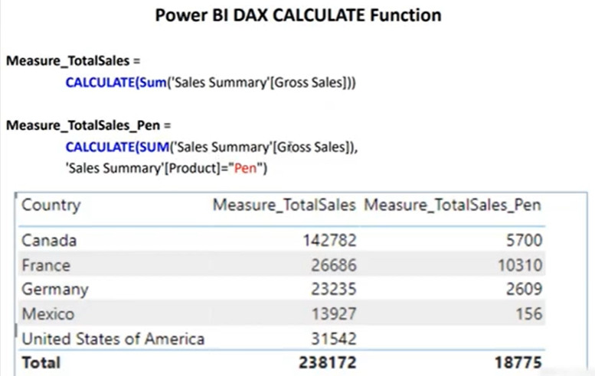

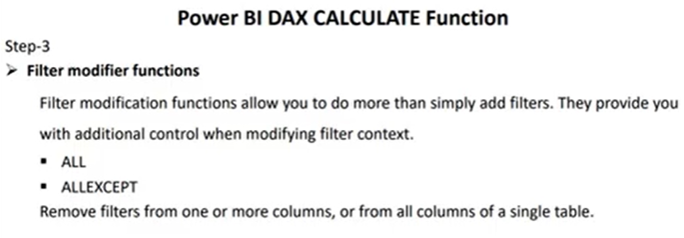

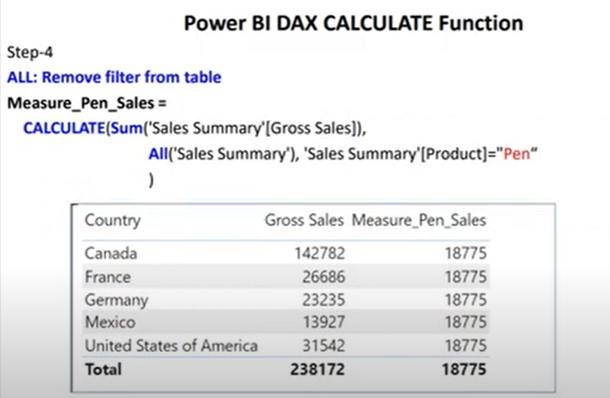

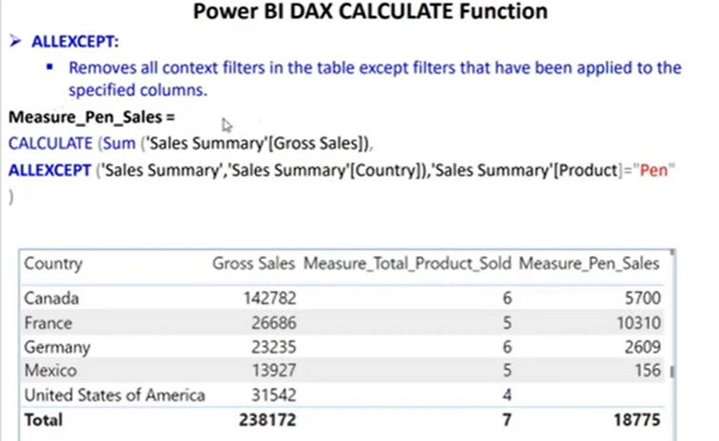

**1] TotalSales_pen = CALCULATE(SUM('Sales Summary'[Gross Sale]), 'Sales Summary'[Product] = "Pen")**

**2] TotalSales_pen_1 = CALCULATE(SUM('Sales Summary'[Gross Sale]),ALL('Sales Summary'), 'Sales Summary'[Product] = "Pen")**

**3] TotalSales_pen_2 = CALCULATE(SUM('Sales Summary'[Gross Sale]),ALL('Sales Summary'[Country]),'Sales Summary'[Product] = "Pen")**

**4] TotalSales_pen_3 = CALCULATE(SUM('Sales Summary'[Gross Sale]),ALLEXCEPT('Sales Summary','Sales Summary'[Country]), 'Sales Summary'[Product] = "Pen")**

**5] TotalSales_pen_4 = CALCULATE(SUM('Sales Summary'[Gross Sale]),ALLEXCEPT('Sales Summary','Sales Summary'[Product]), 'Sales Summary'[Product] = "Pen")**

**3] DAX - LookUpValue**

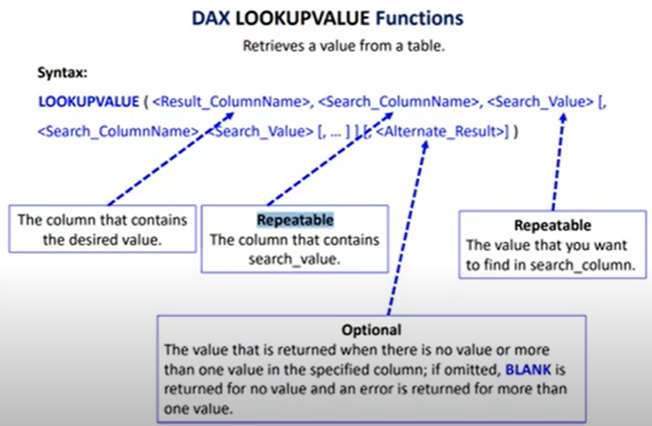

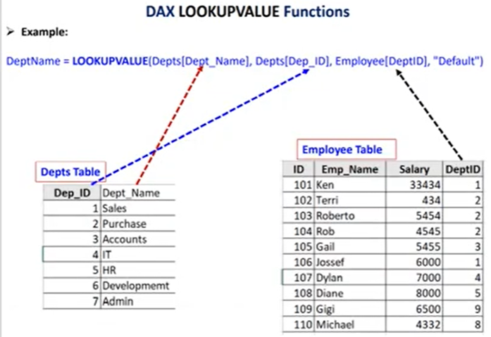

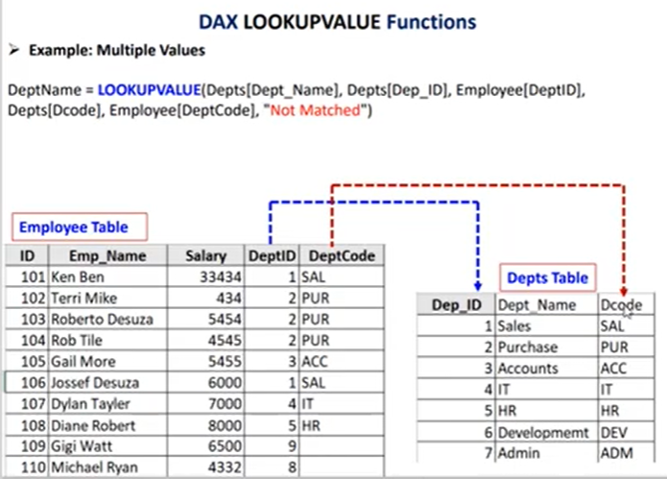

**Dept_name = LOOKUPVALUE(Depts[Dept_Name],Depts[Dep_ID],Employee[DeptID],Depts[Dcode],Employee[DeptCode],"Not Found")**

**4]** **DAX | PATH | PATHITEM | PATHCONTAINS | PATHLENGTH**

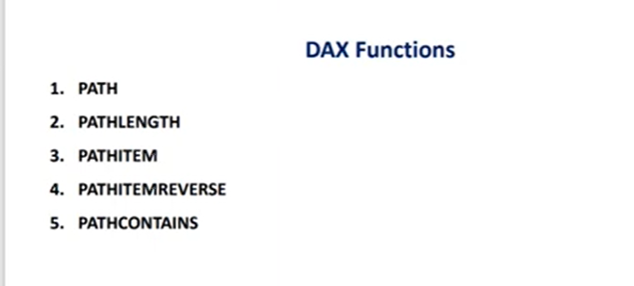

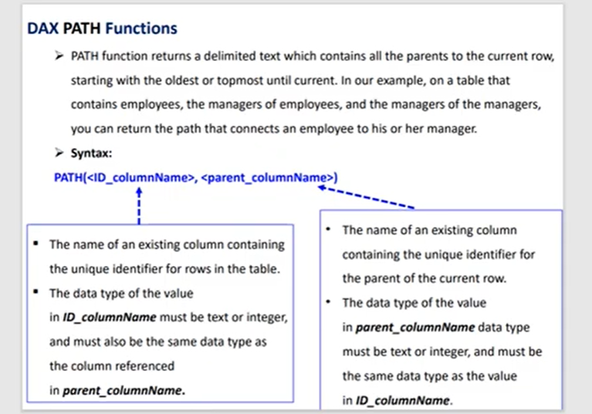

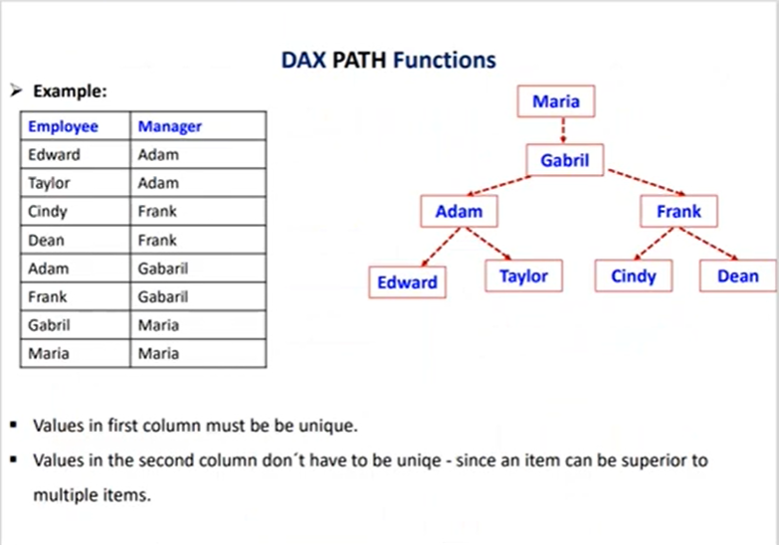

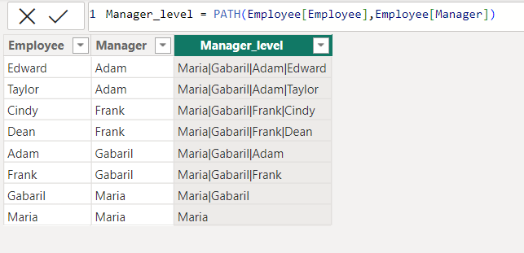

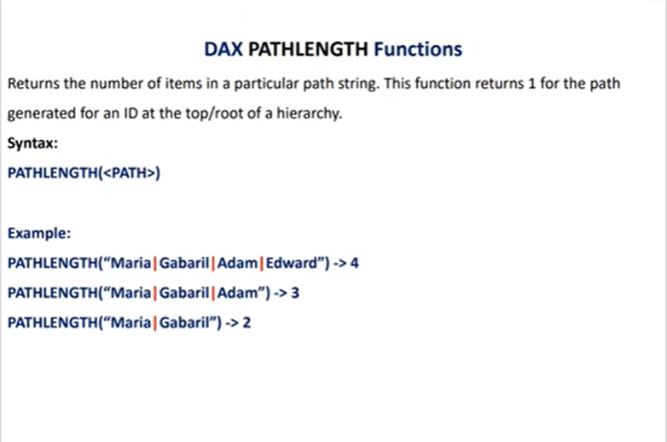

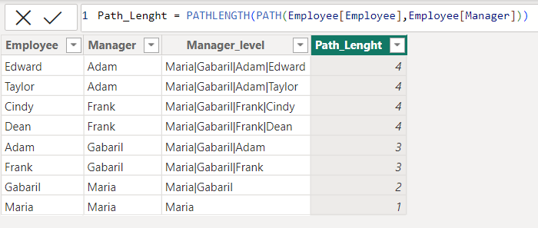

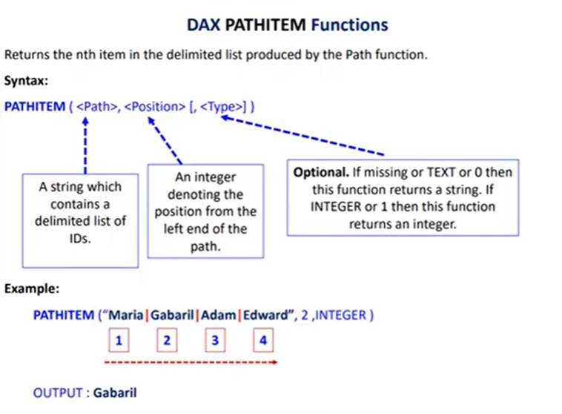

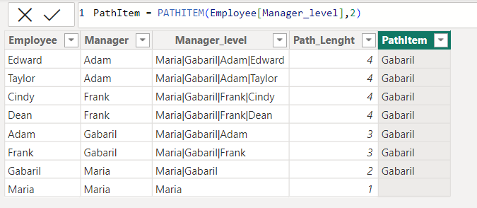

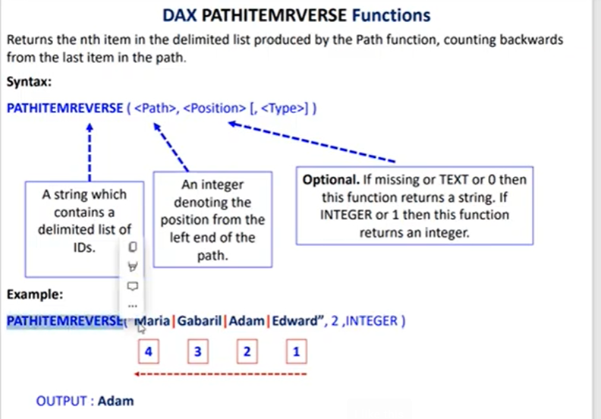

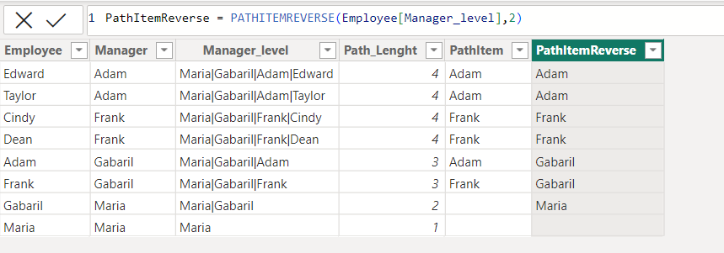

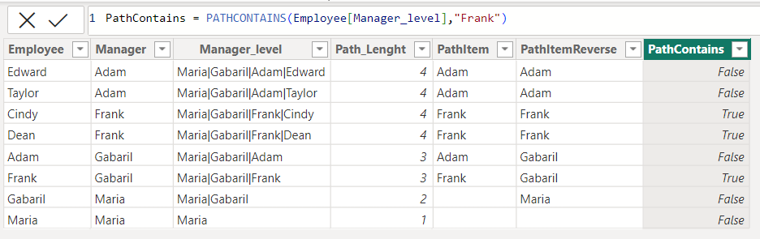

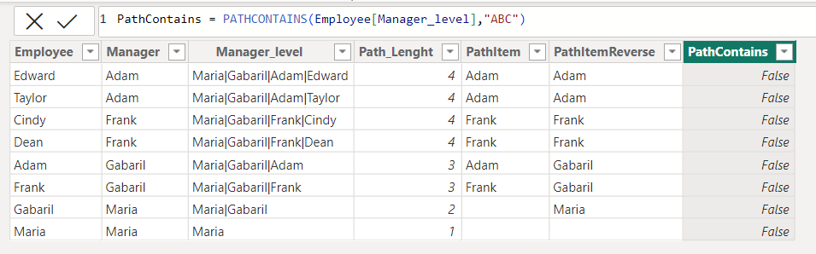

**5] Nested IF Statement**

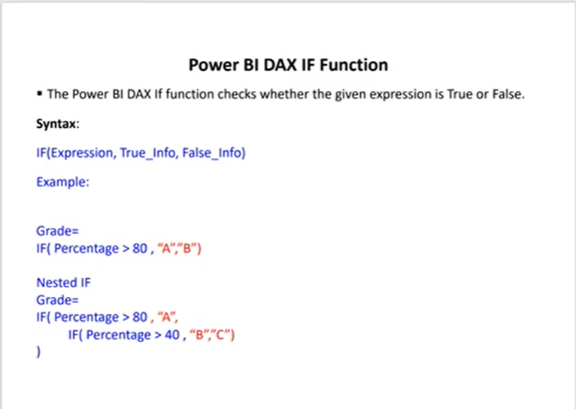

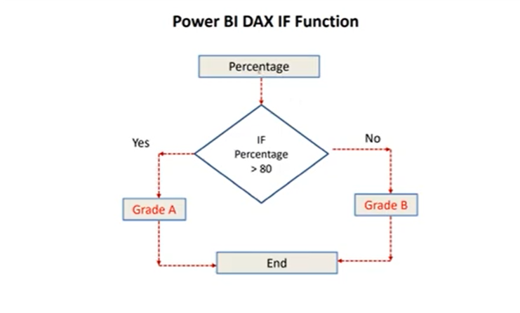

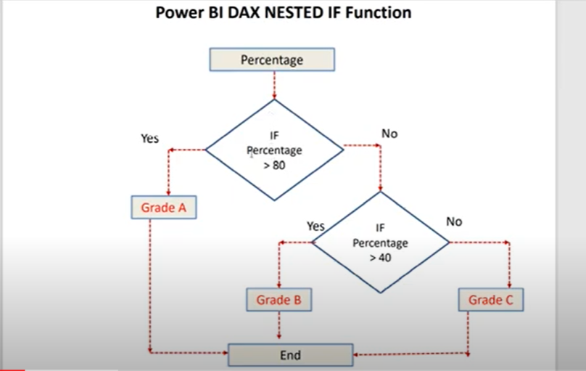

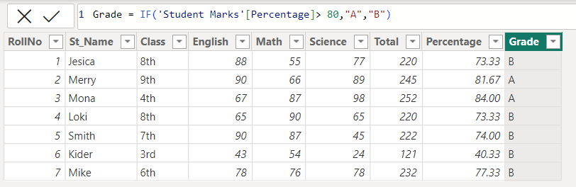

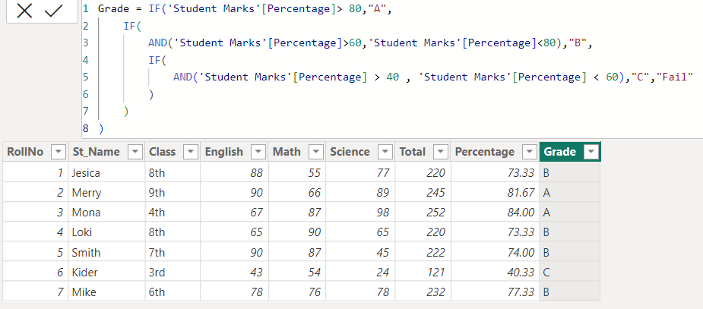

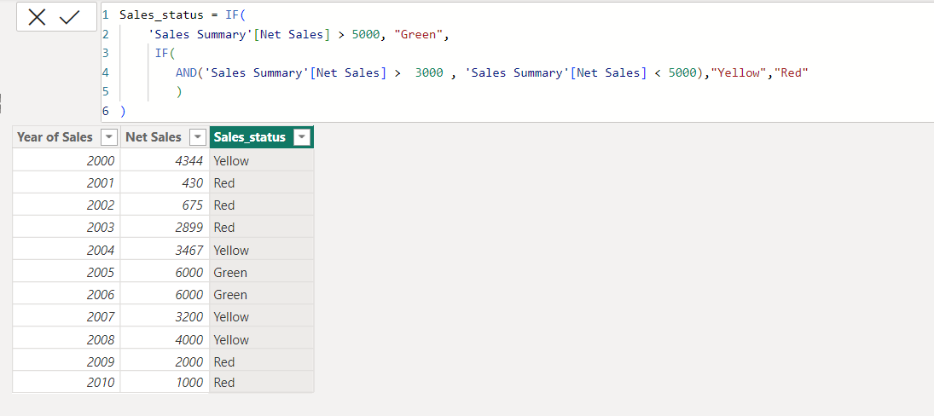

**6] DAX Date Functions**

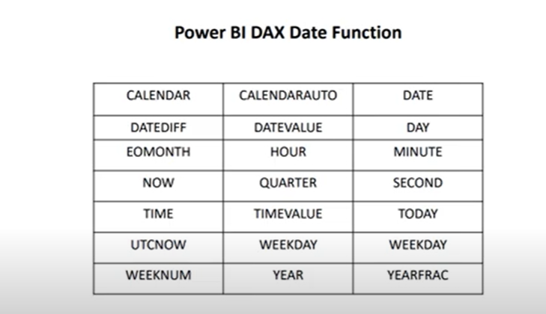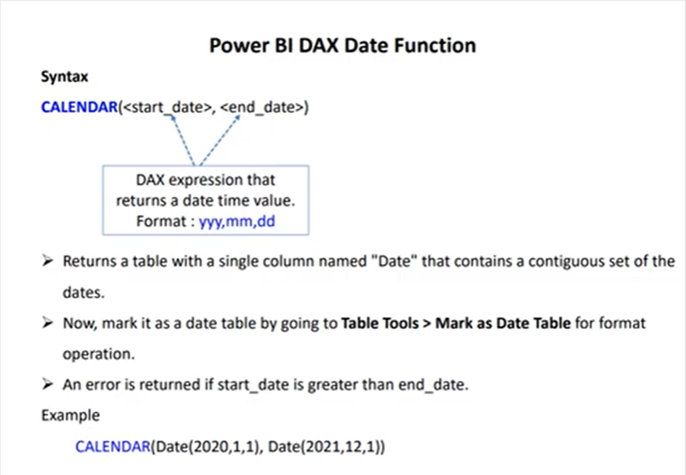

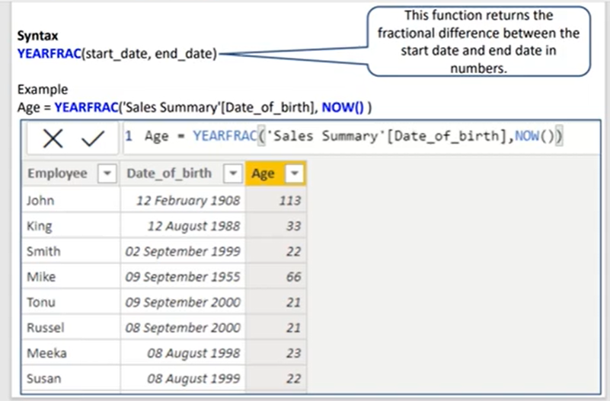

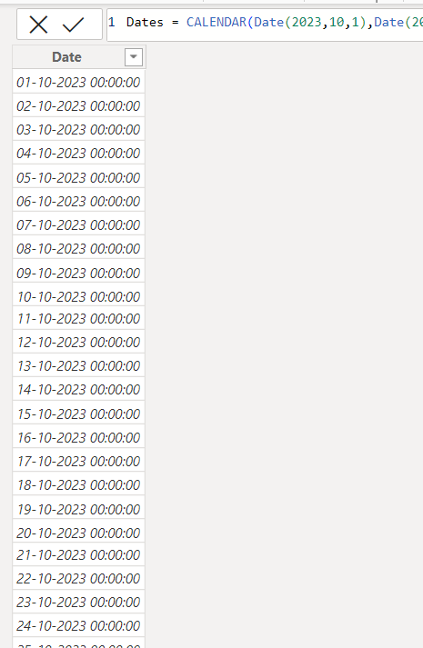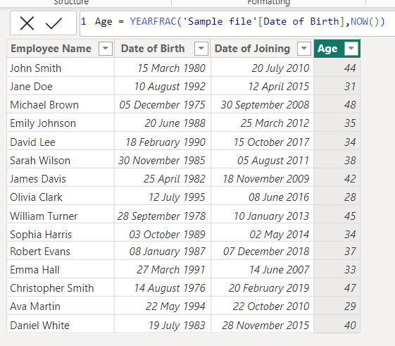

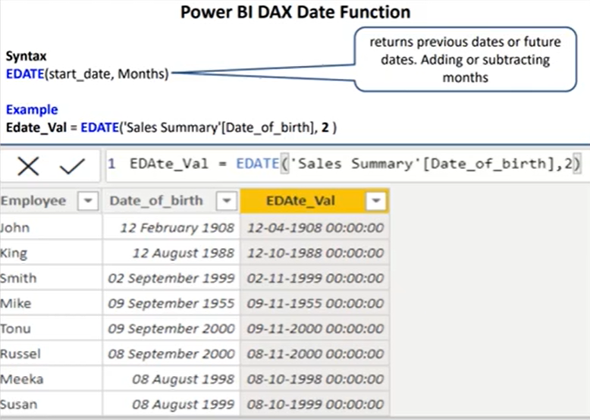

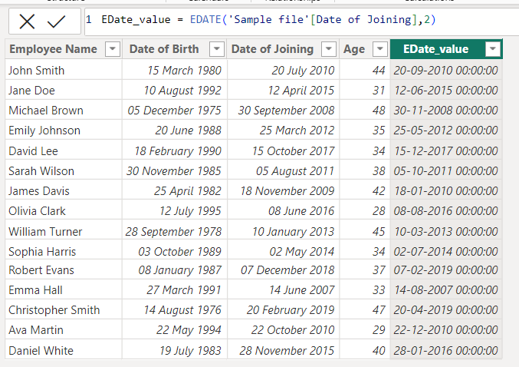

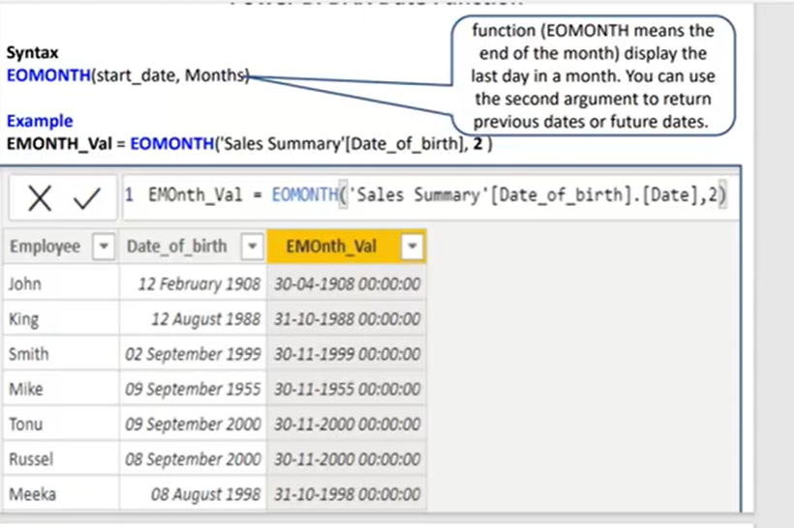

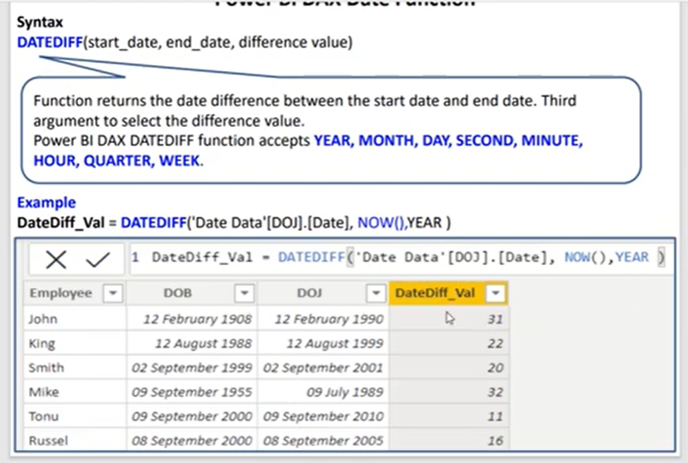

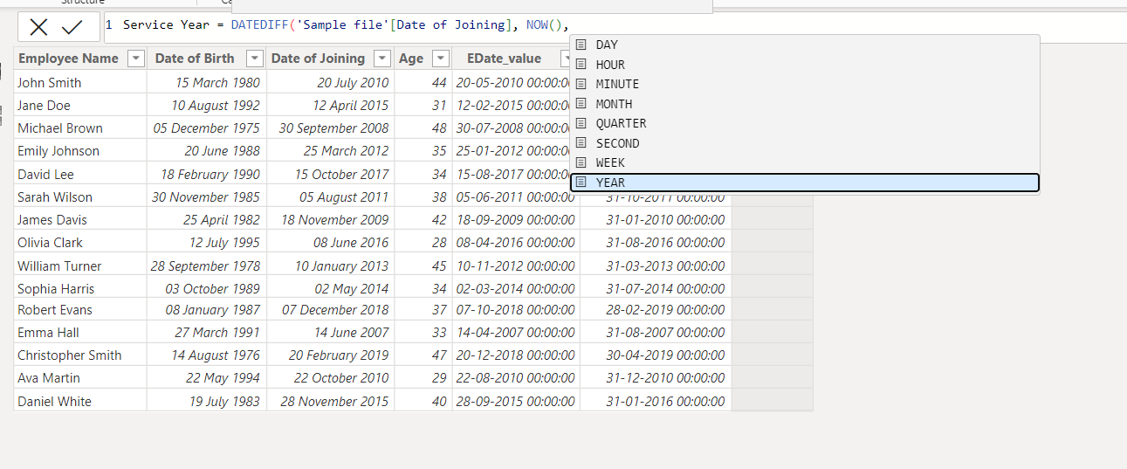

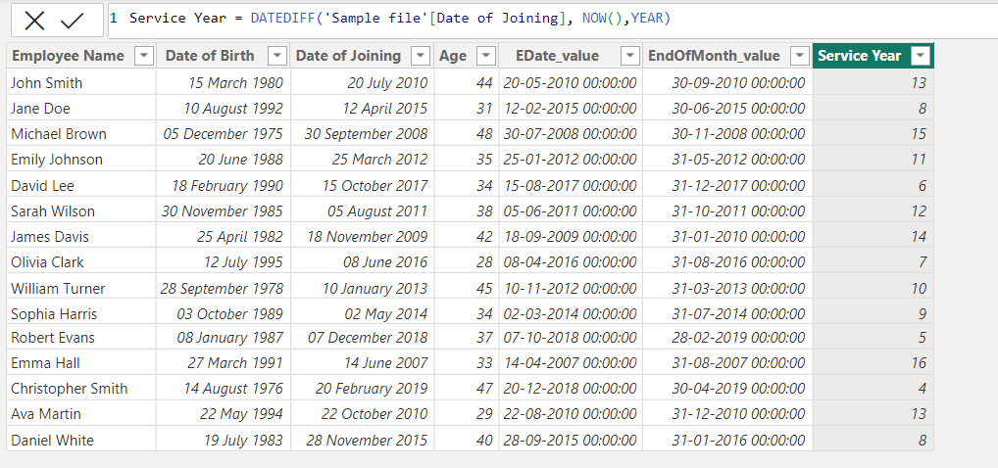

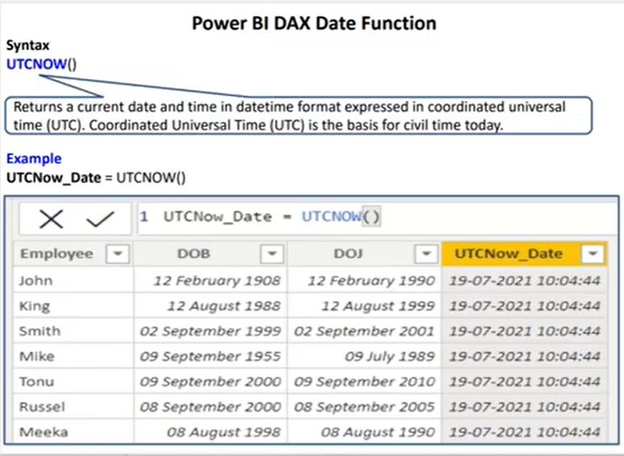

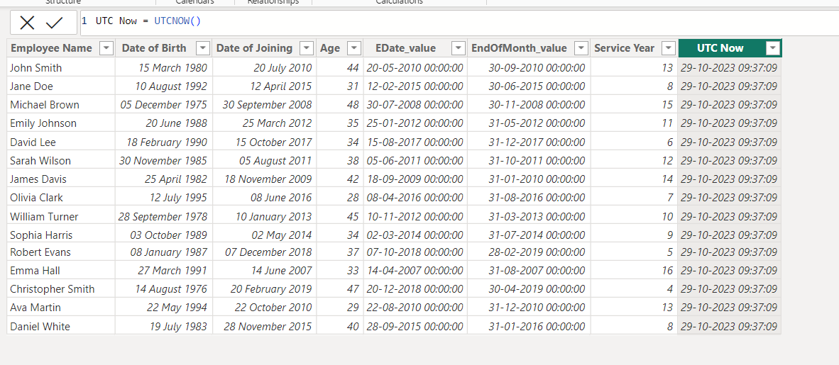

**7] Logical Functions in DAX**

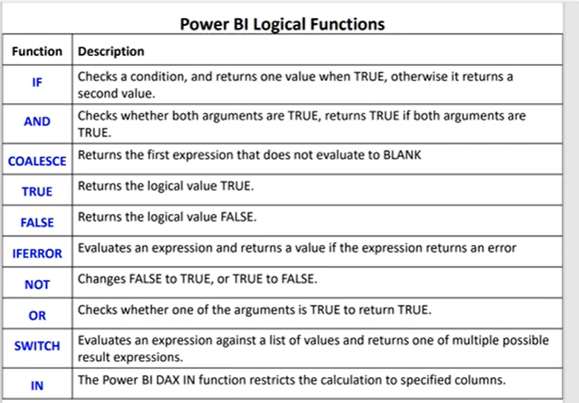

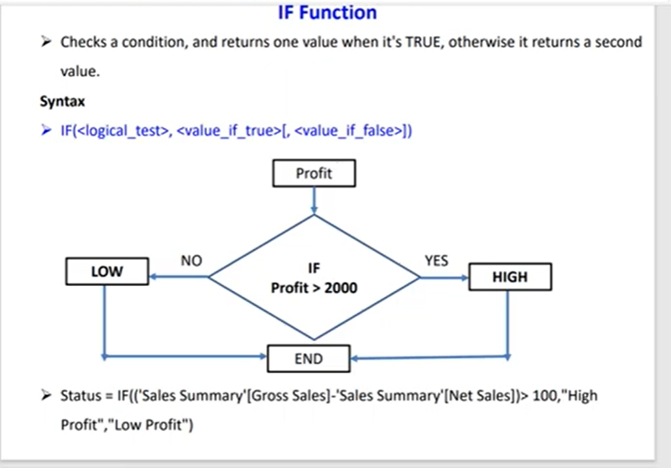

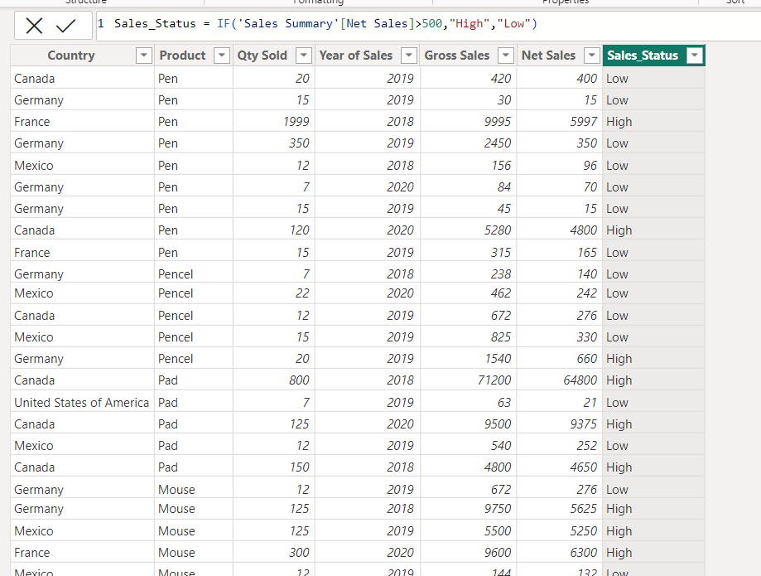

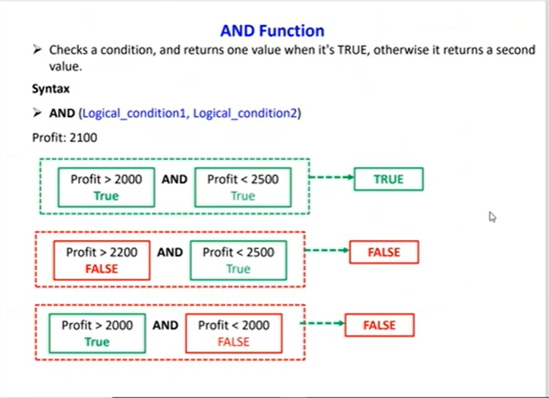

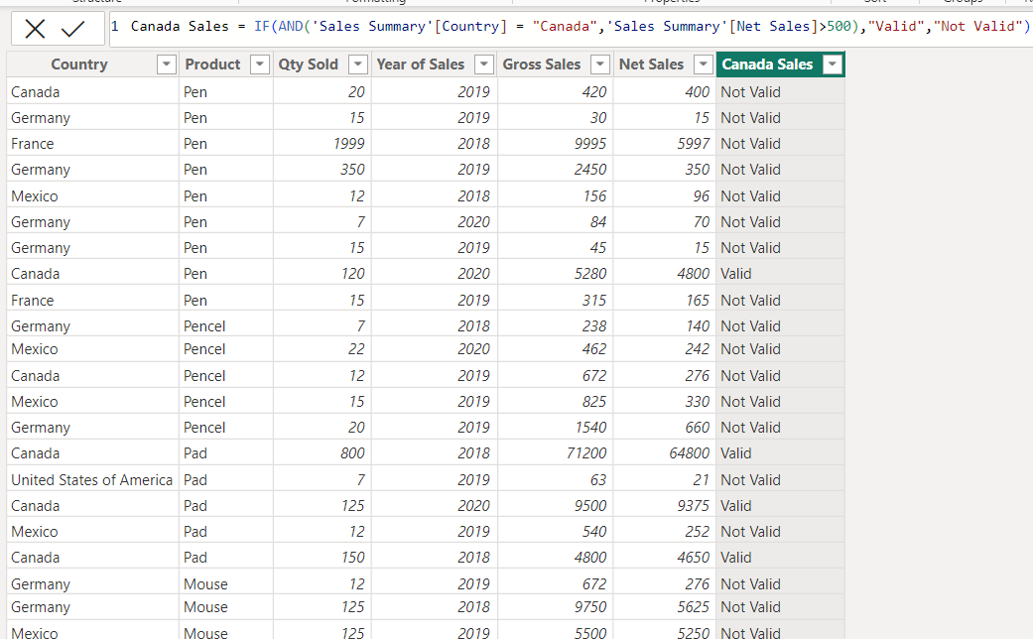

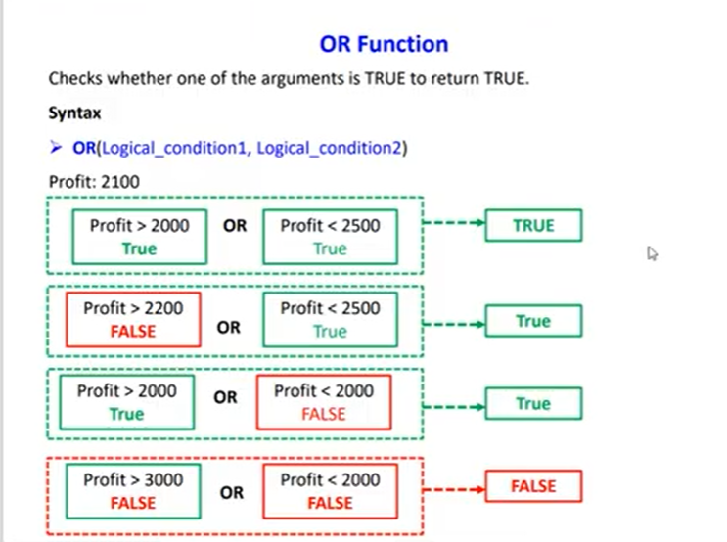

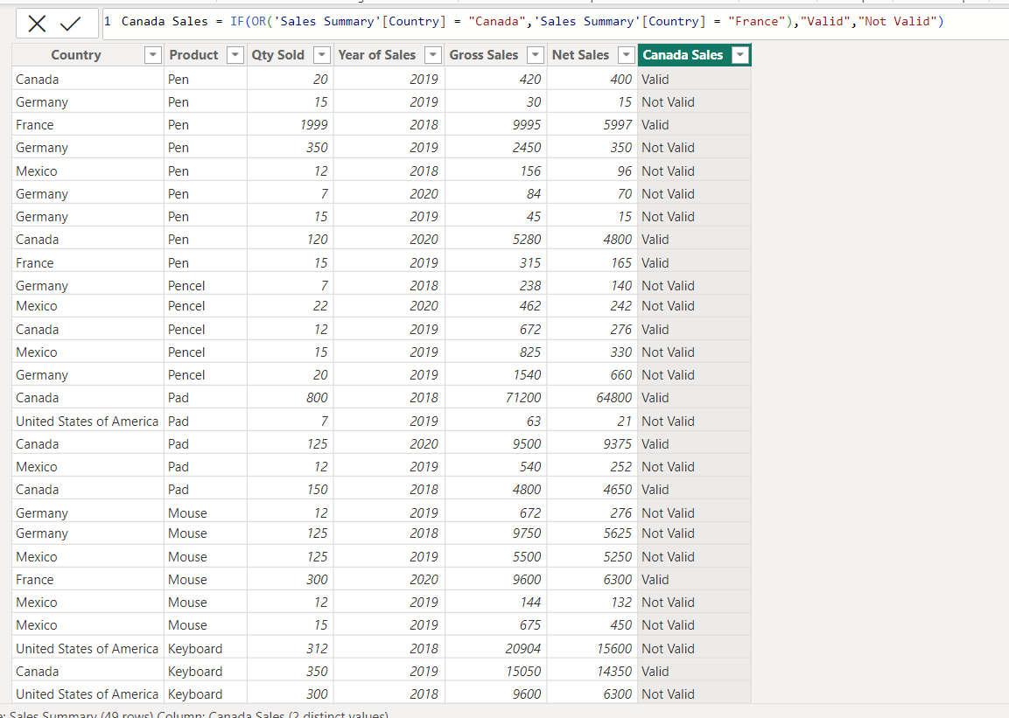

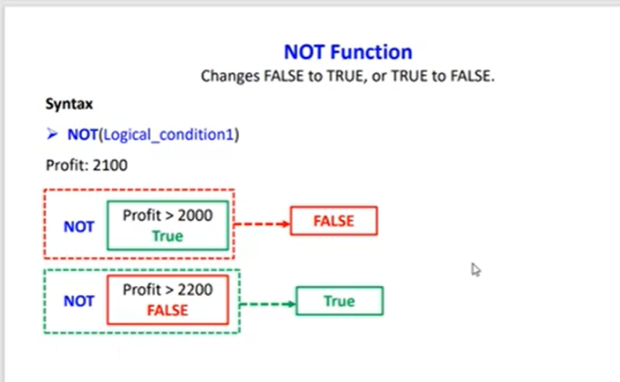

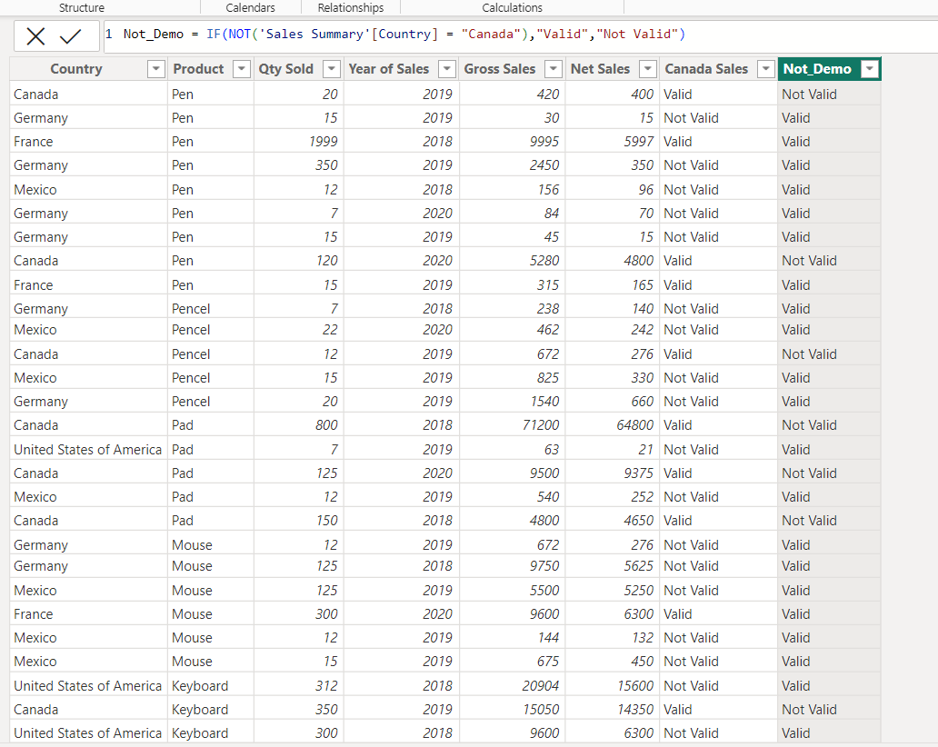

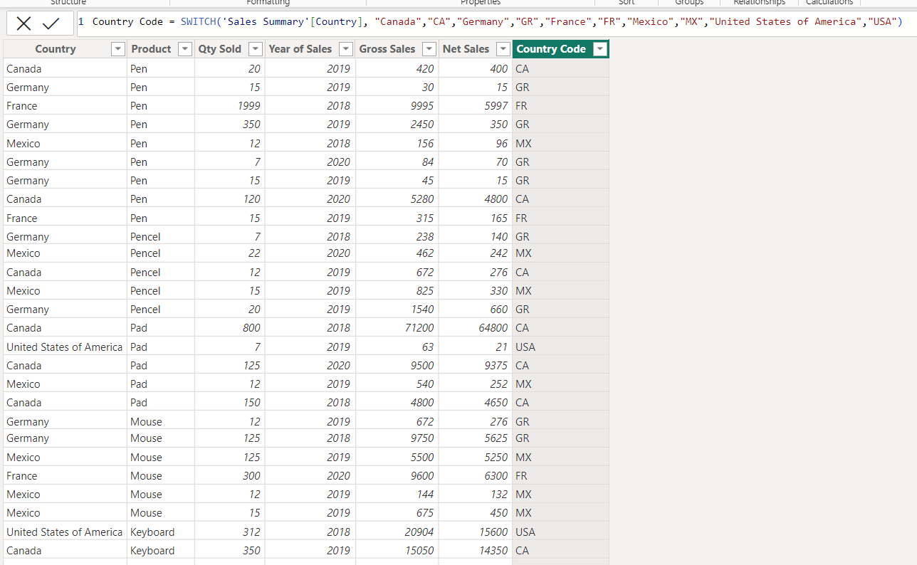

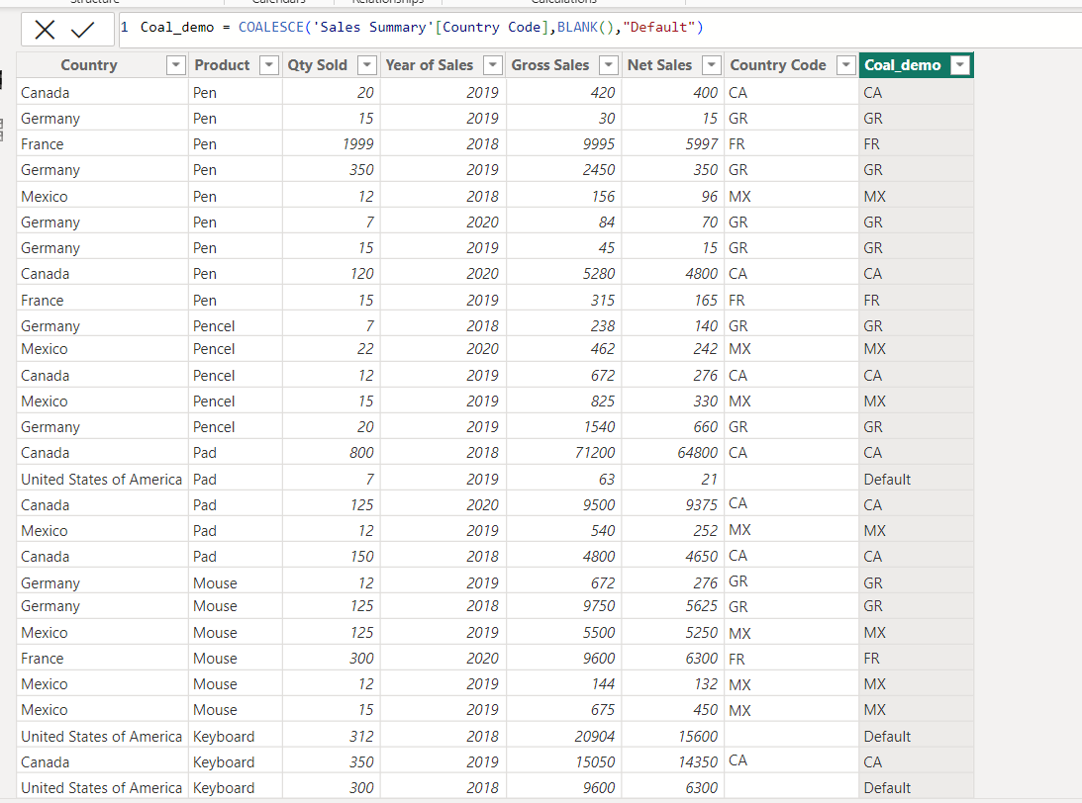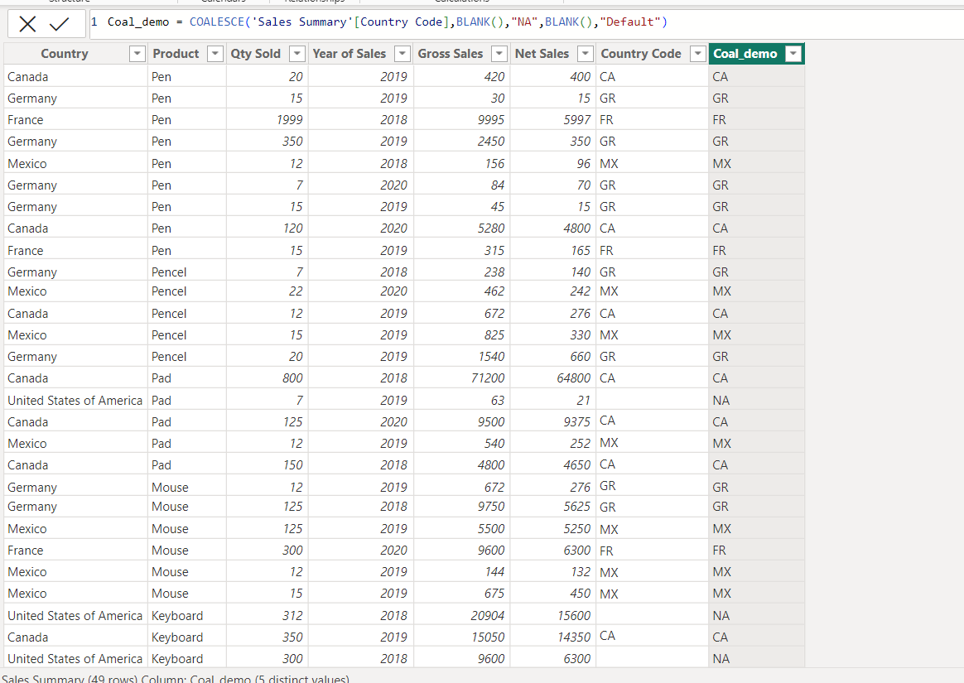

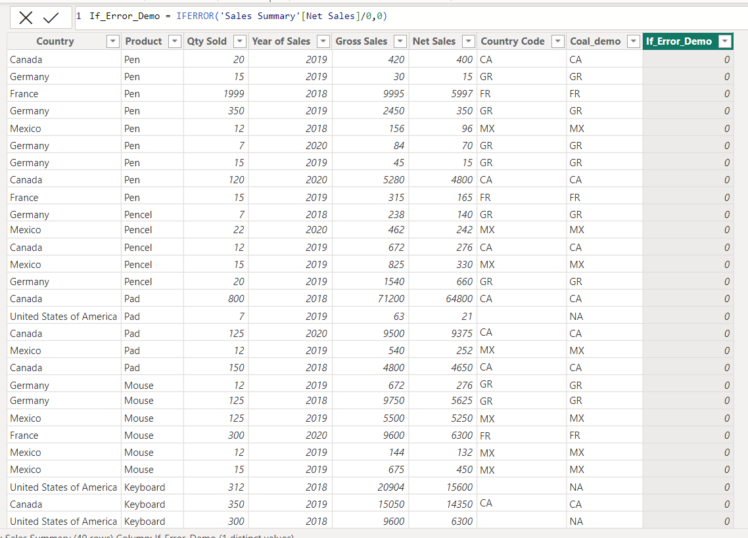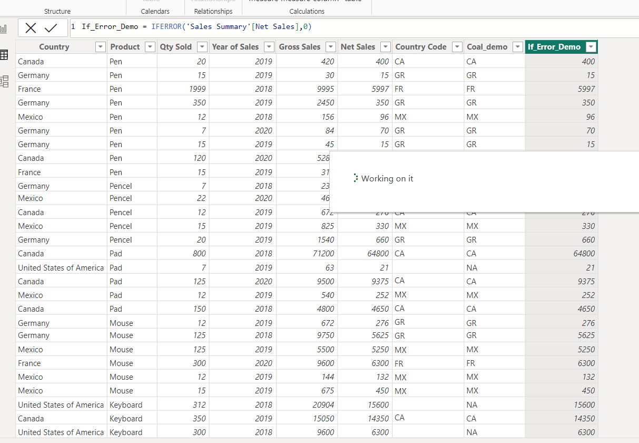

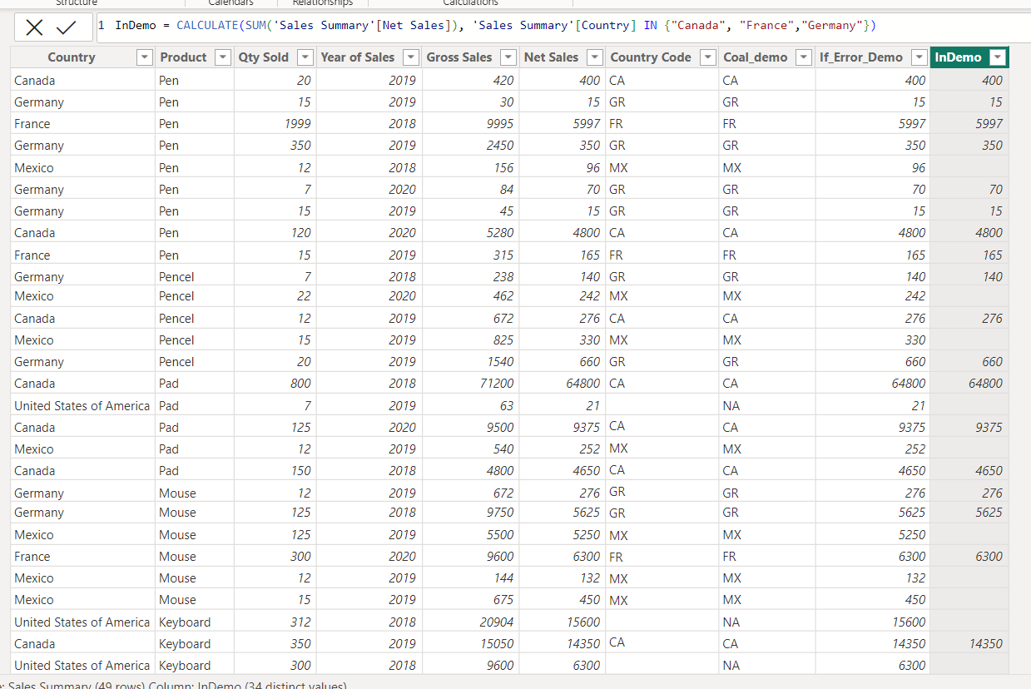

**8] Sum vs SumX**

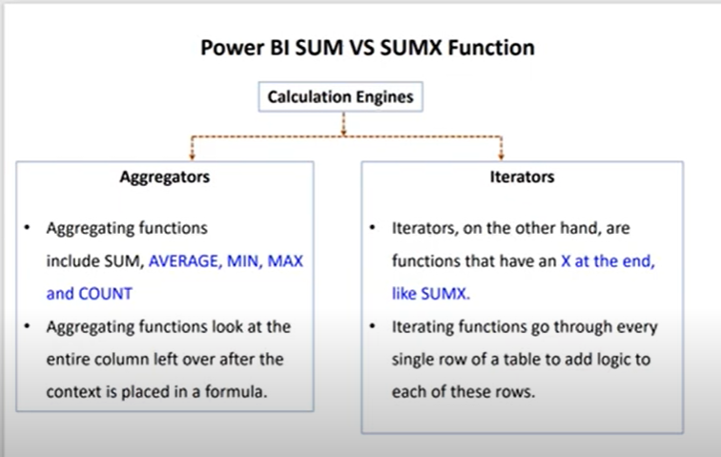

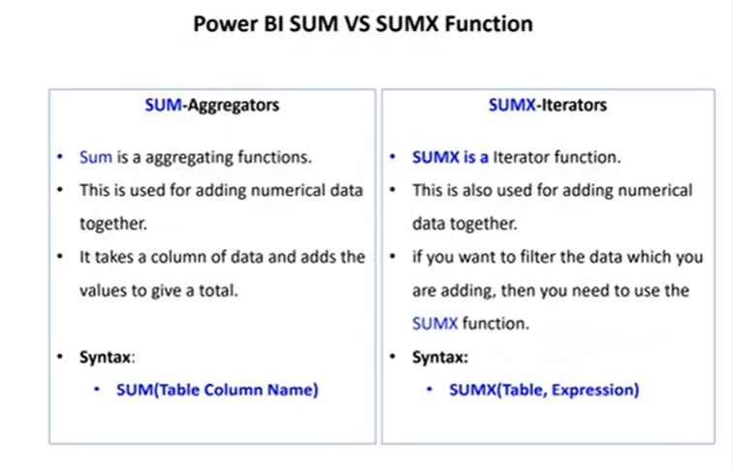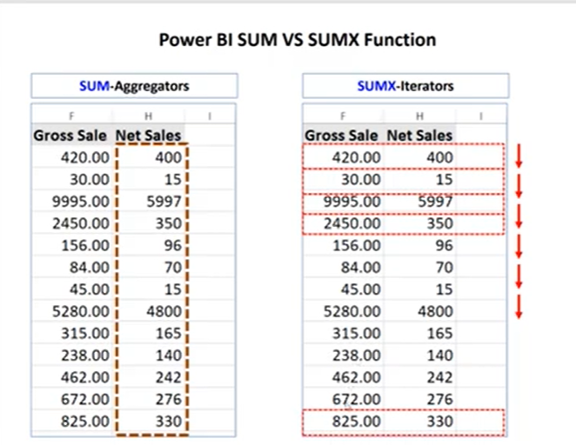

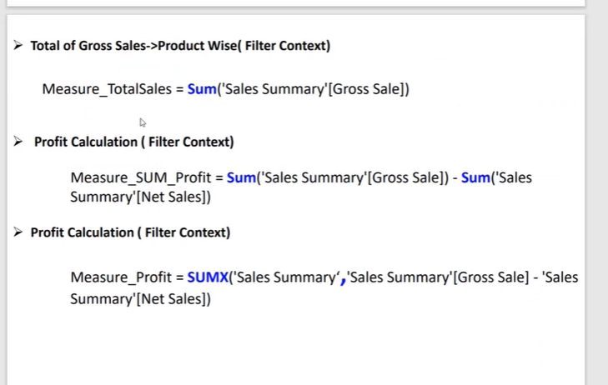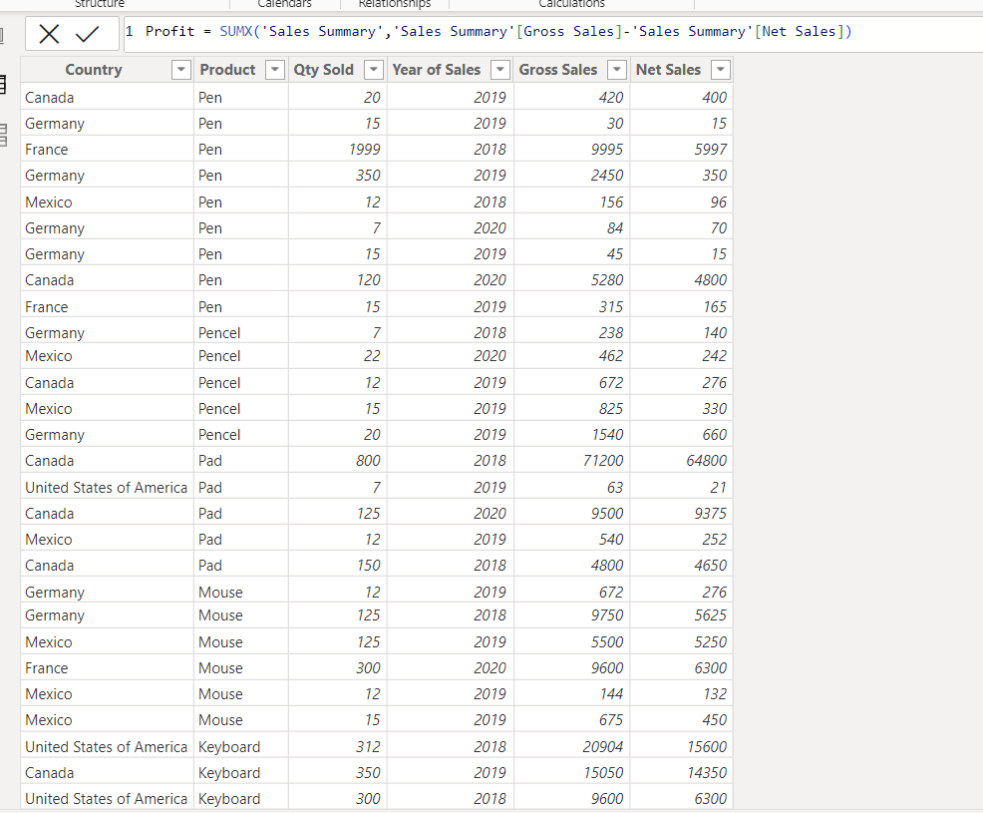

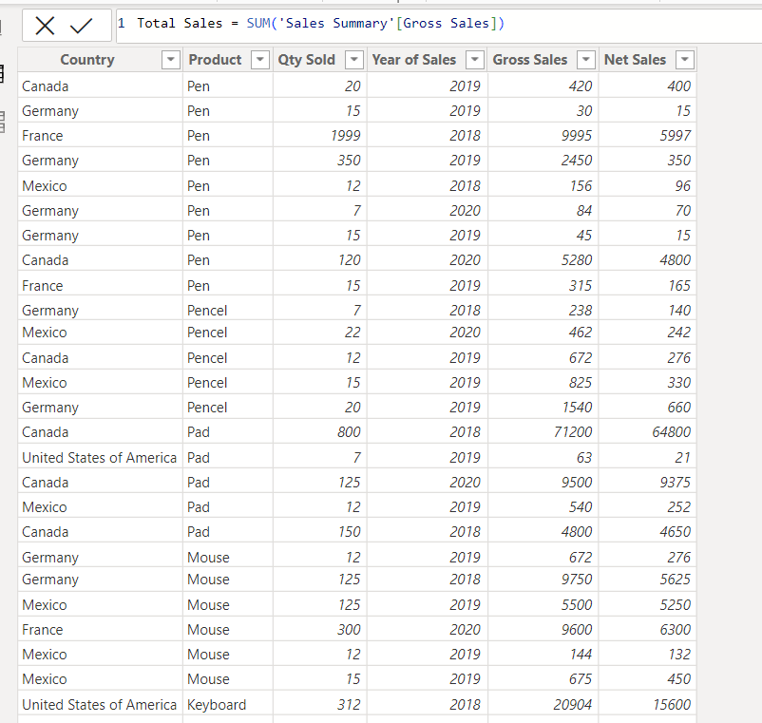

**9] Split Column in DAX**

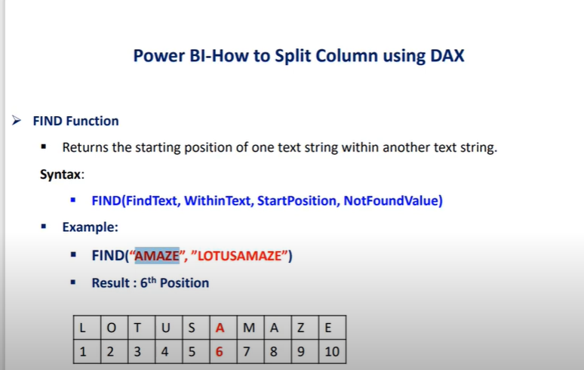

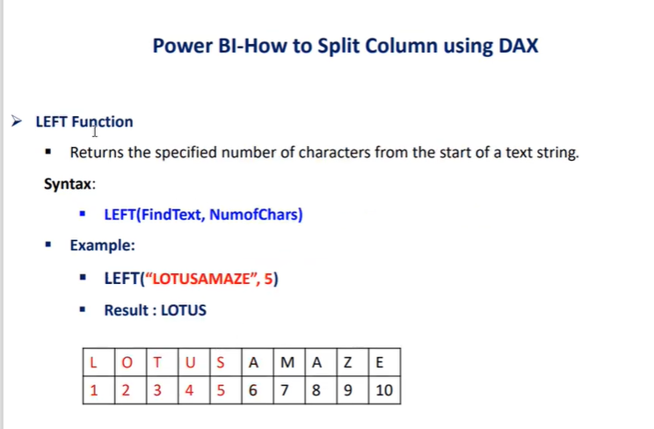

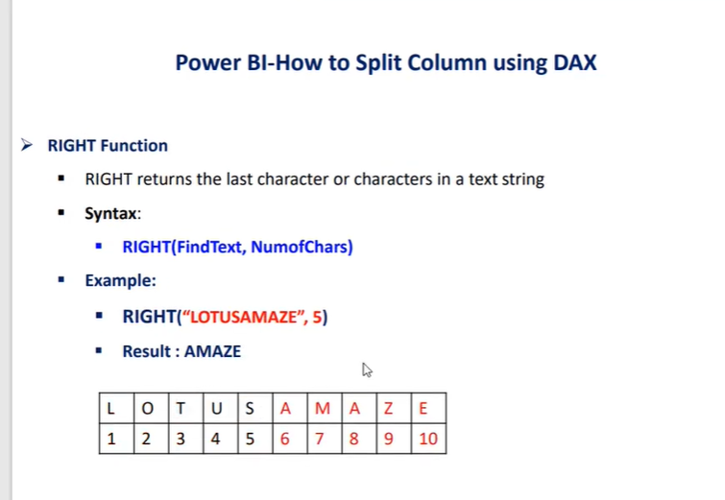

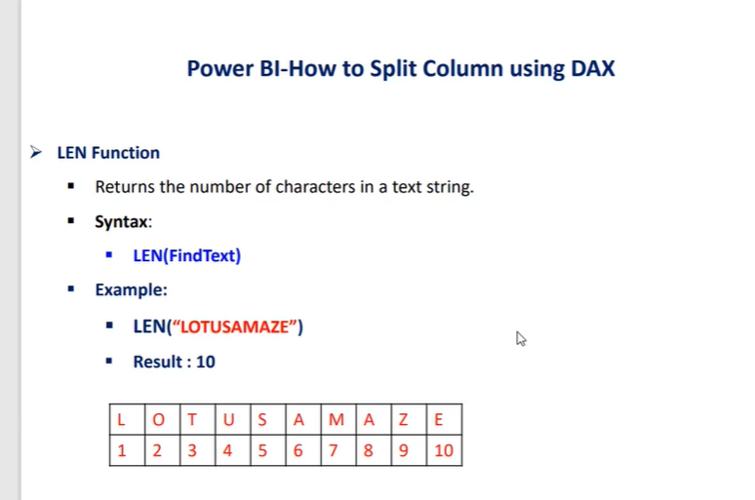

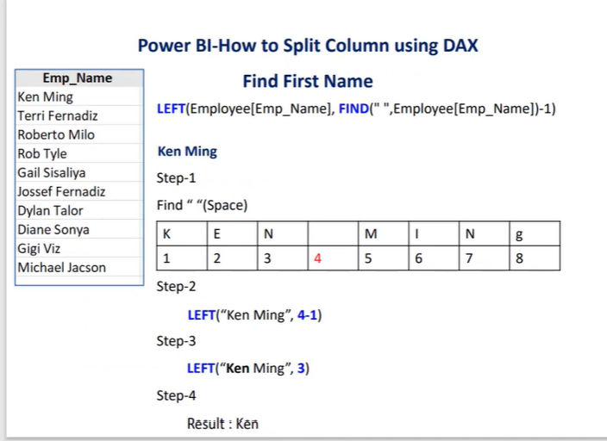

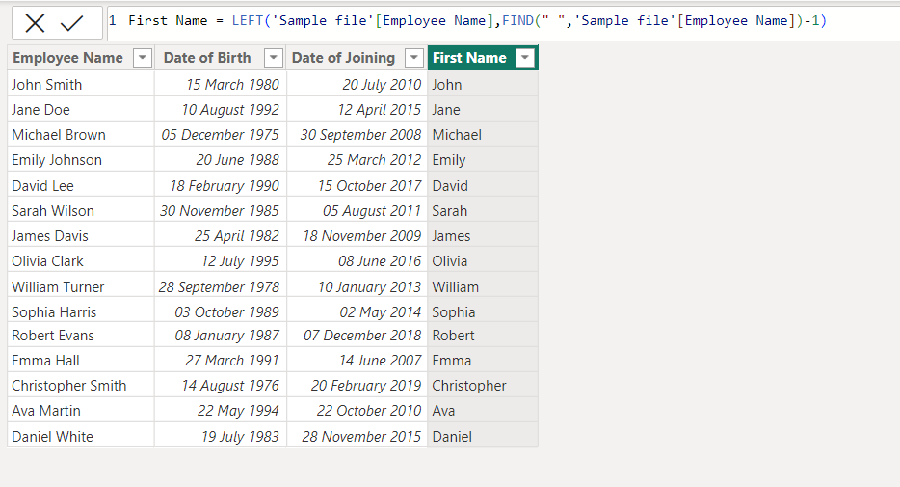

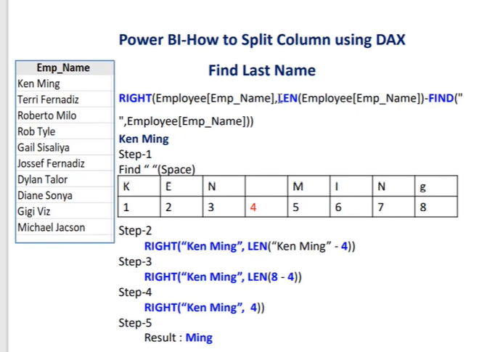

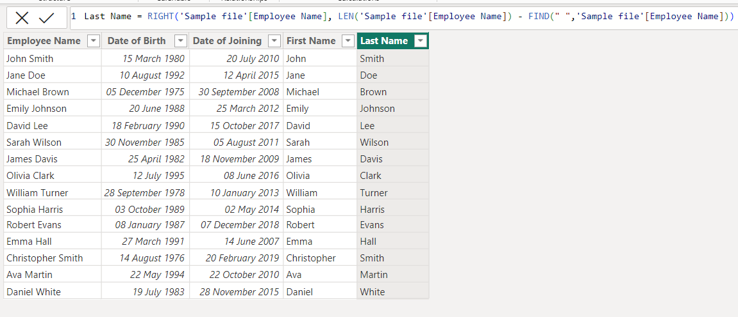

**10] Calendar vs CalendarAuto**

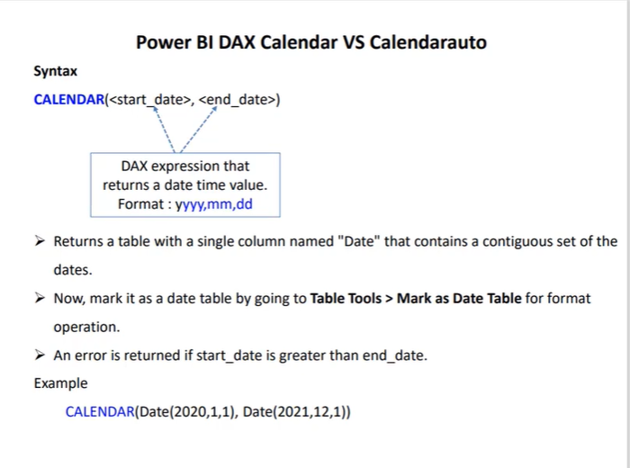

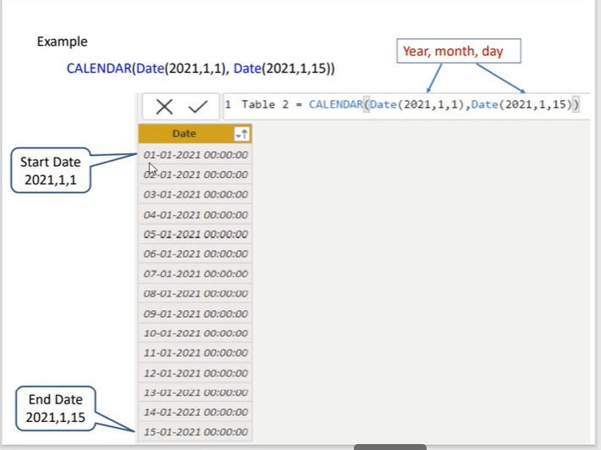

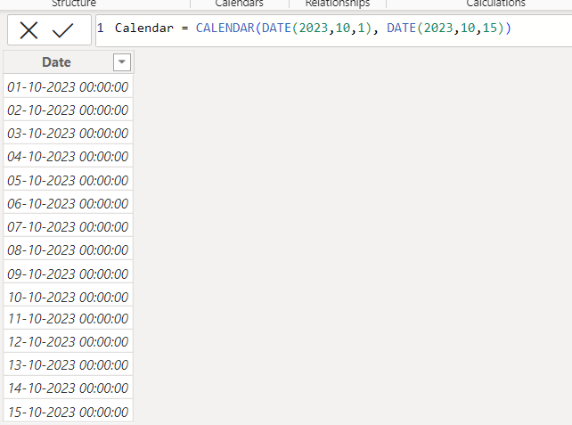

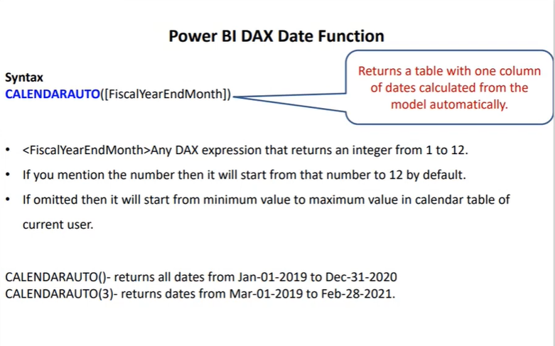

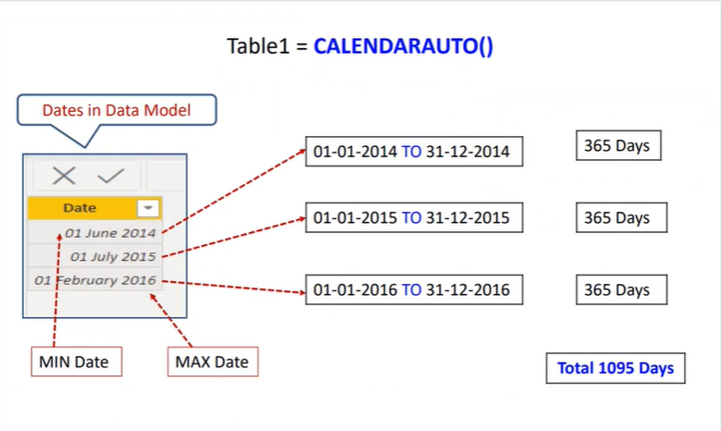

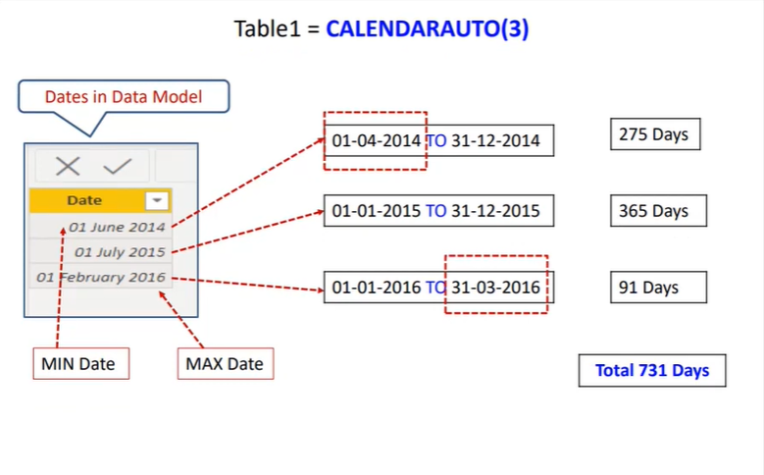

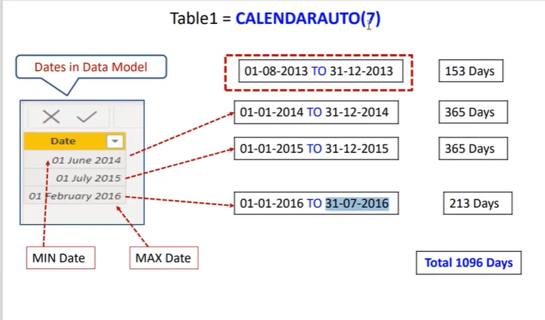

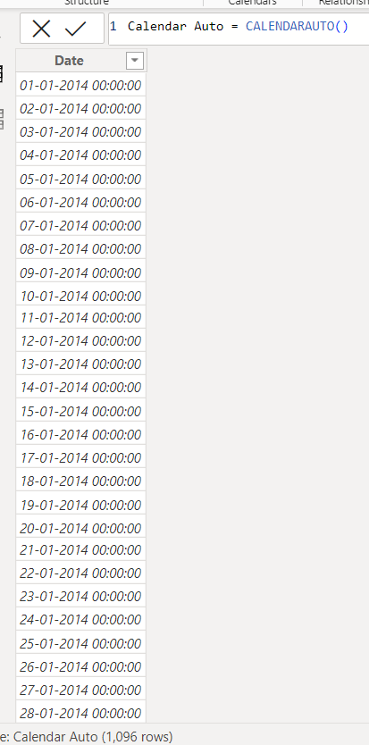 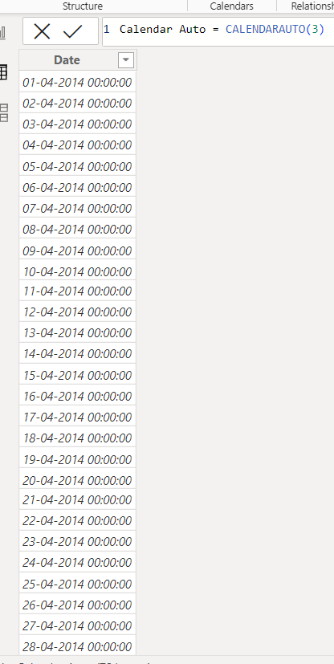

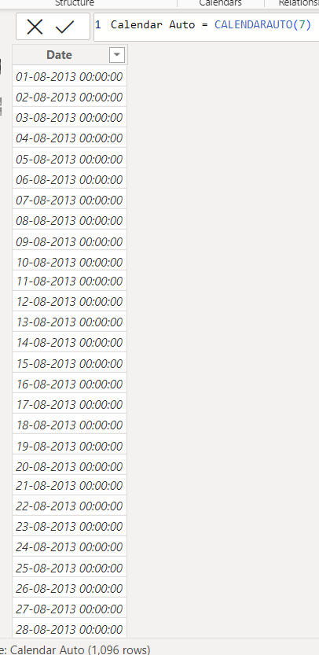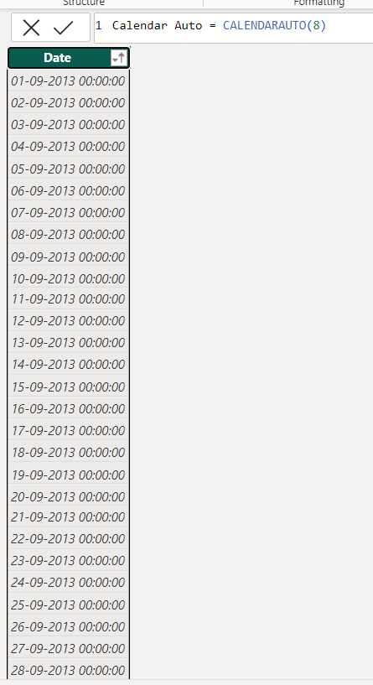

# **11] Count, Counta, Countblank, Countrows, Countx, Countax**

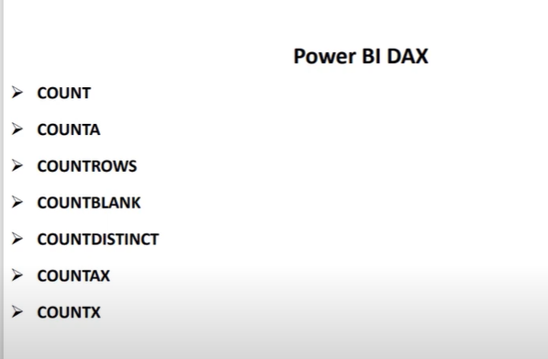

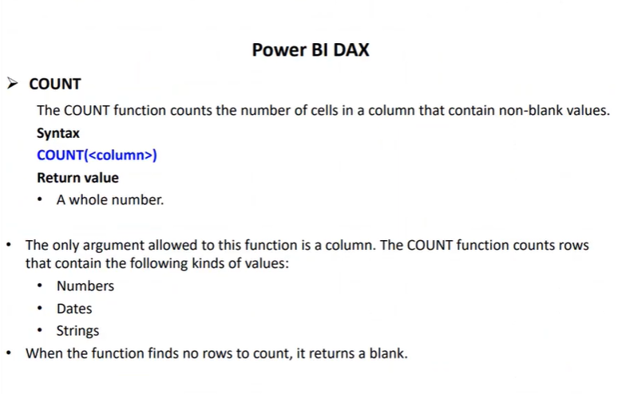

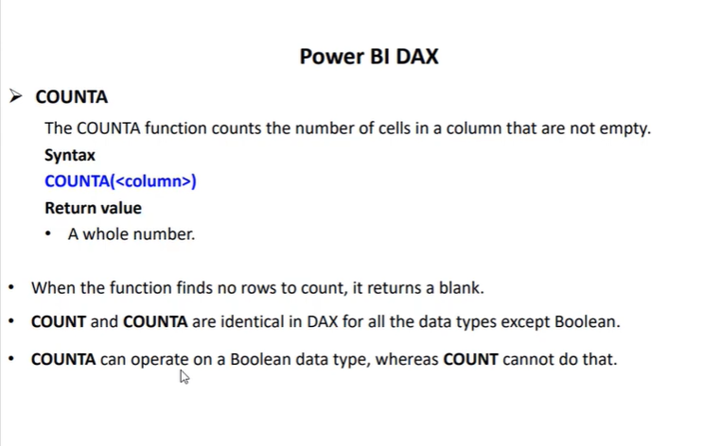

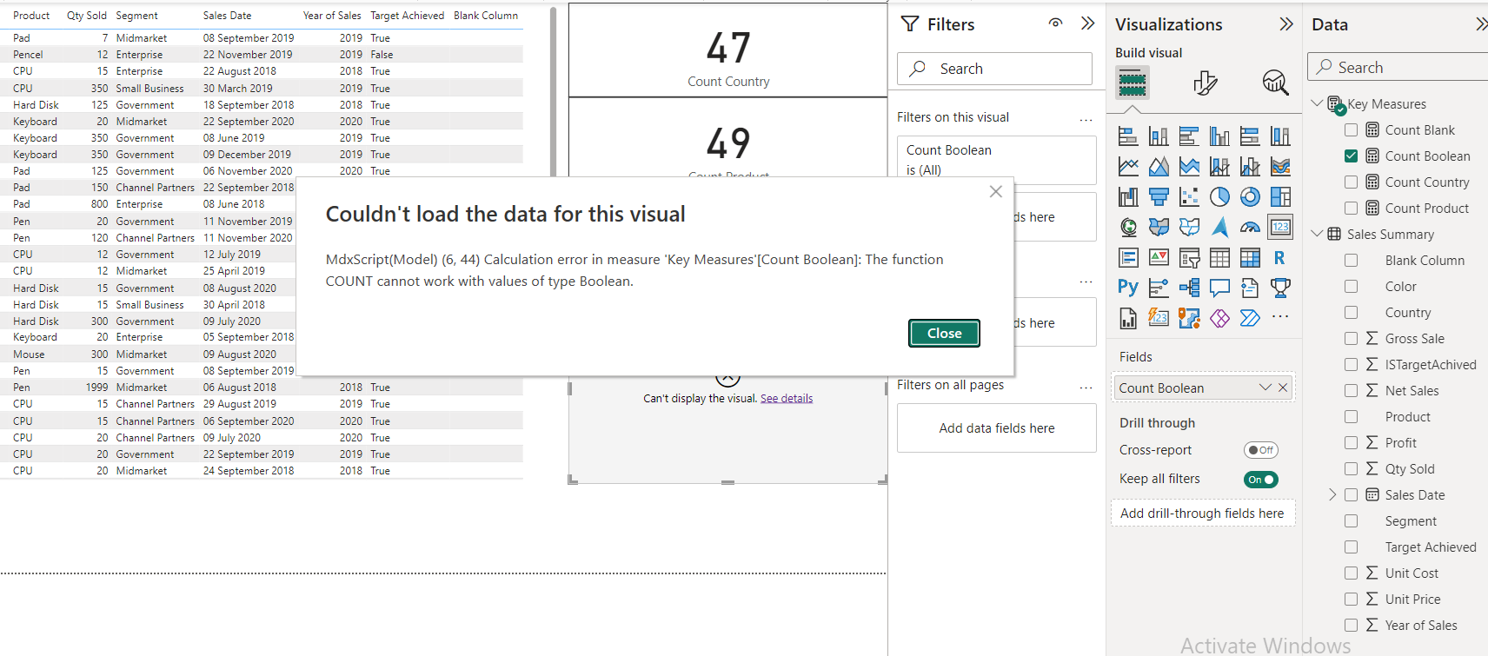

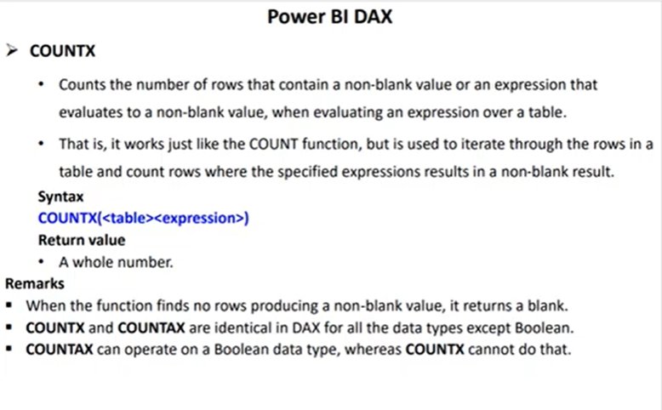

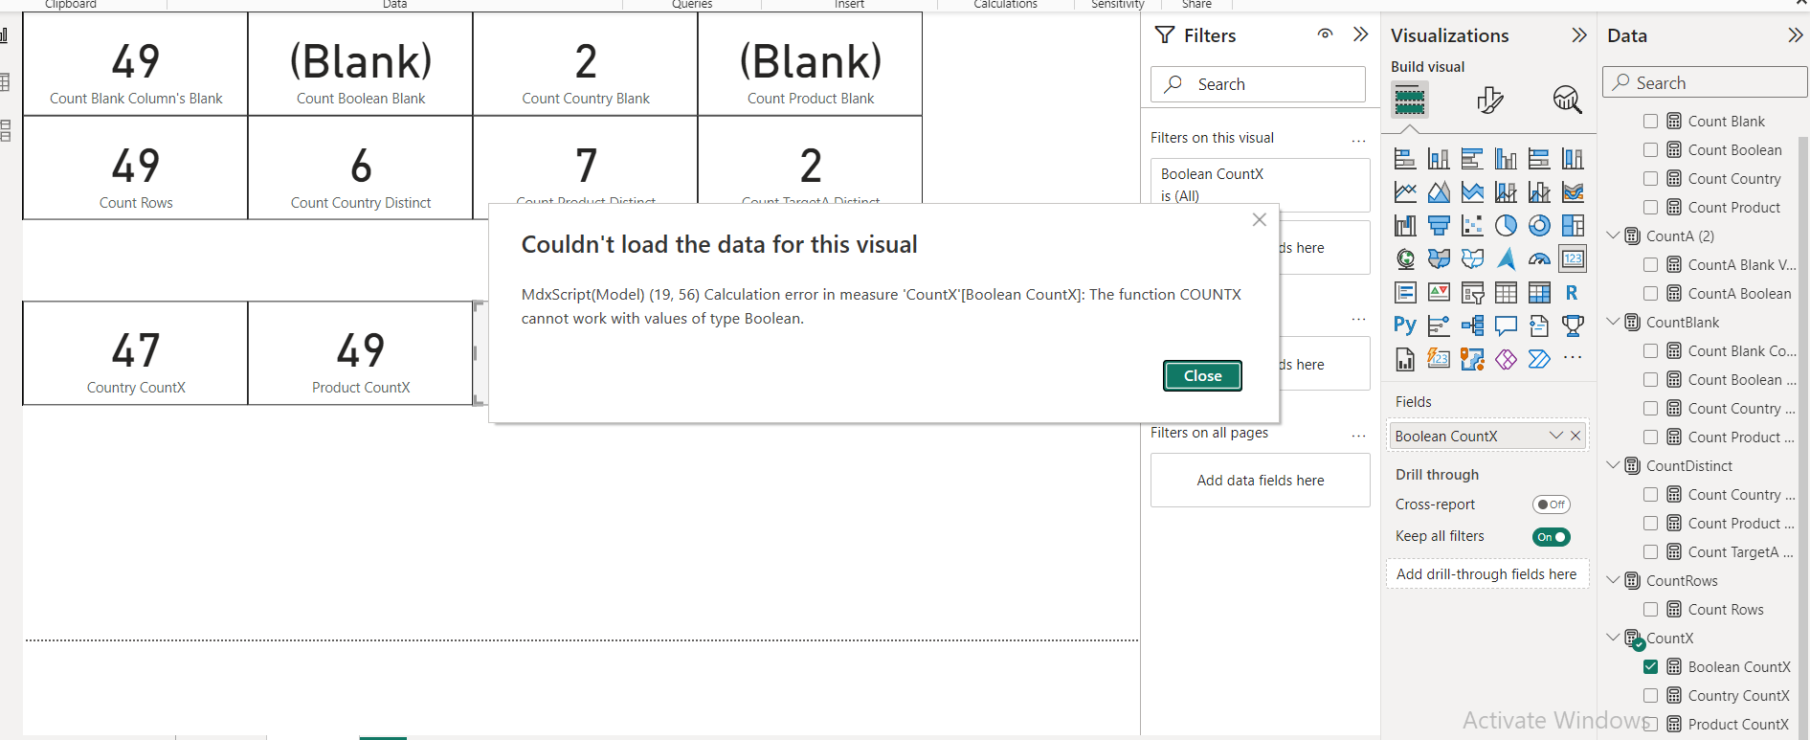

**Count Blank = COUNT('Sales Summary'[Blank Column])**

**CountA Boolean = COUNTA('Sales Summary'[Target Achieved])**

**Country CountAX = COUNTAX('Sales Summary','Sales Summary'[Country])**

**Count Country Blank = COUNTBLANK('Sales Summary'[Country])**

**Count Country Distinct = DISTINCTCOUNT('Sales Summary'[Country])**

**Count Rows = COUNTROWS('Sales Summary')**

**Country CountX = COUNTX('Sales Summary','Sales Summary'[Country])**

**12] All vs Allselected vs AllExcept**

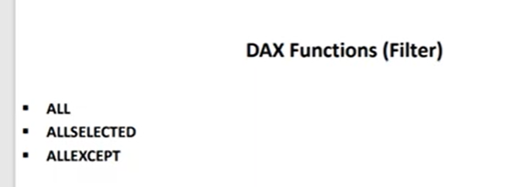

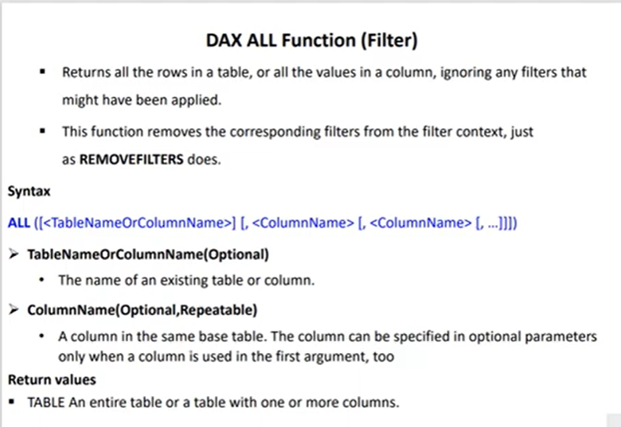

**All total Sum = CALCULATE(SUM(Sheet1[Net Sales]), ALL())**

**AllProductSales = CALCULATE(SUM(Sheet1[Net Sales]),ALL(Sheet1[Product]))**

**All parameters in ALL() are optional.**

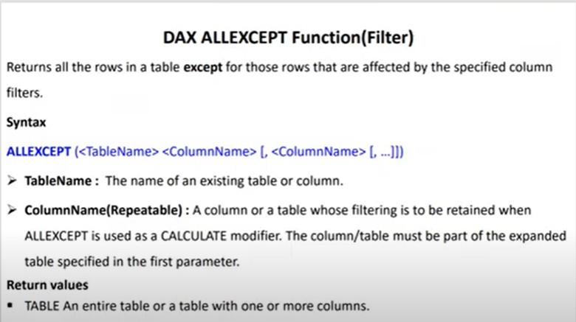

**AllExcept Sales = CALCULATE(SUM(Sheet1[Net Sales]), ALLEXCEPT(Sheet1,Sheet1[Country]))**

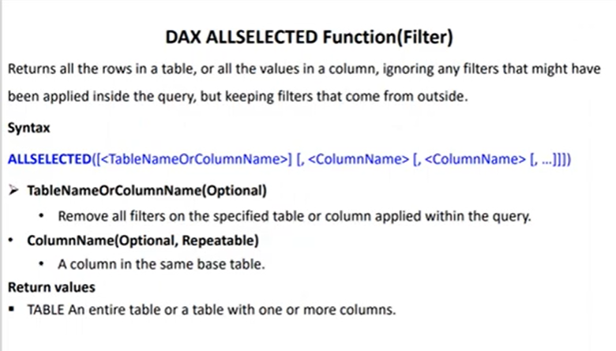

**AllSelected Sales = CALCULATE(SUM(Sheet1[Net Sales]), ALLSELECTED(Sheet1[Product]))**

**13] Min vs MinA vs Minx**

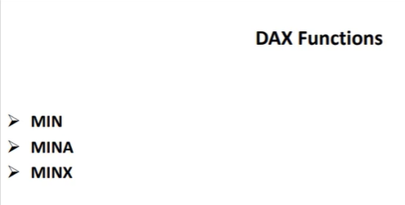

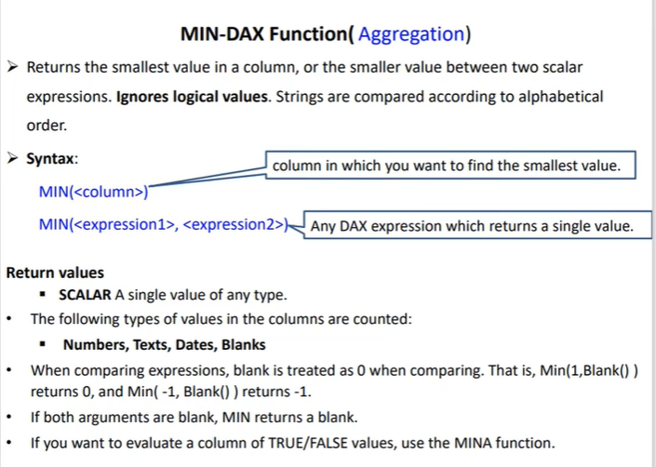

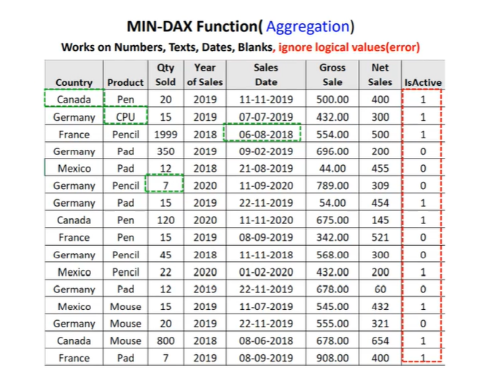

**Min Between Country = MIN('Sales Summary'[Country]) - Canada**

**Min between -1 and blank = MIN(-1, BLANK()) = -1**

**Min between 1 and blank = MIN(1, BLANK()) = blank**

**Min between blank and blank = MIN(BLANK(), BLANK()) = blank**

**Min Between dates = MIN('Sales Summary'[Sales Date]) = smallest date like 7-2-2018**

**Min Between Quantity Sold = MIN('Sales Summary'[Qty Sold])= smallest number**

**Min of Boolean = MIN('Sales Summary'[IsActive]) - doesn’t work**

**For boolean values we get this error:**

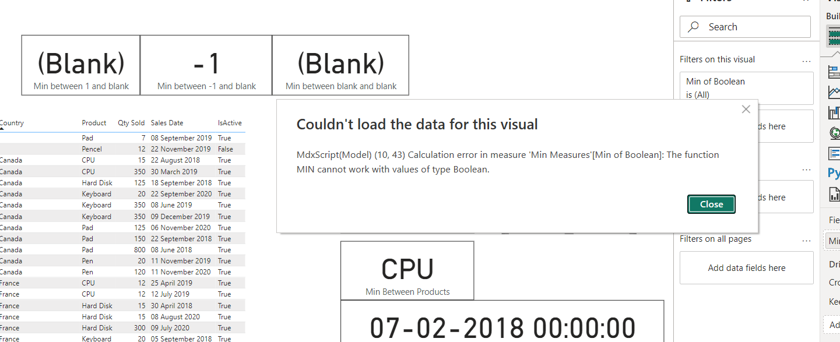

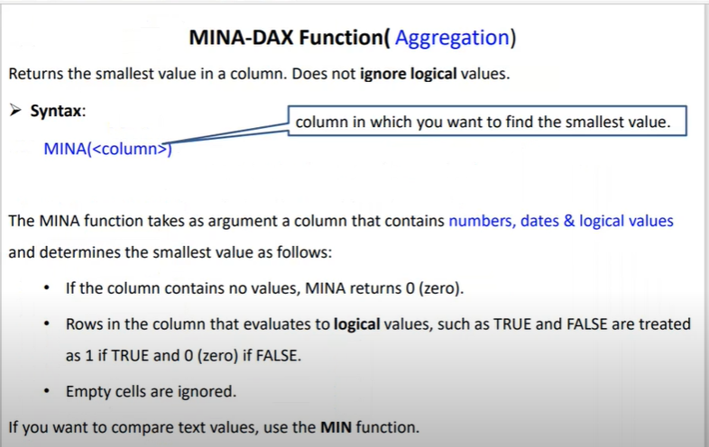

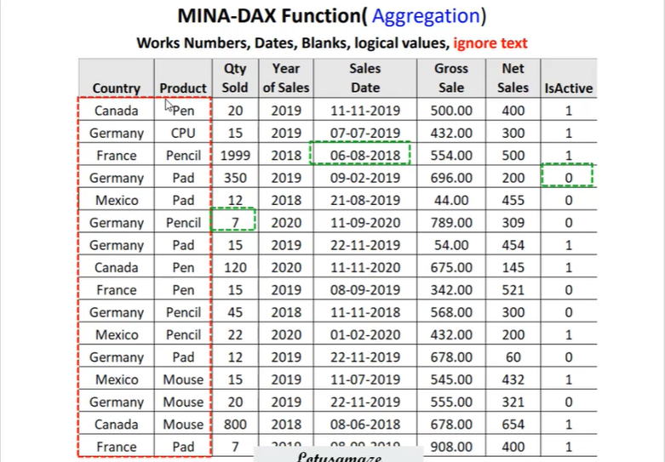

**MinA Boolean = MINA('Sales Summary'[IsActive]) - 0 as 0 is for false**

**MinA Country = MINA('Sales Summary'[Country]) - doesn’t work for text**

**MinA Dates = MINA('Sales Summary'[Sales Date]) - smallest date in column**

**MinA Qty Sold = MINA('Sales Summary'[Qty Sold]) - smallest Number in column**

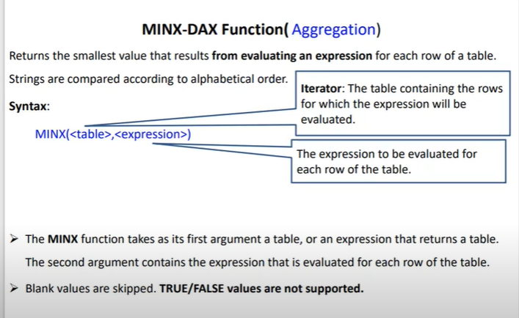

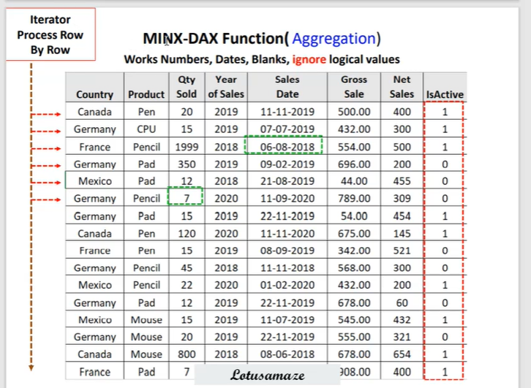

**MinX Qty Sold for Canada = MINX(FILTER('Sales Summary','Sales Summary'[Country] = "Canada"), 'Sales Summary'[Qty Sold])**

**MinX Product = MINX(FILTER('Sales Summary','Sales Summary'[Qty Sold] > 100), 'Sales Summary'[Product])**

**14] Average vs AverageA vs Averagex**

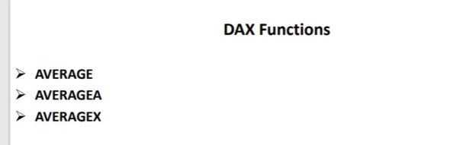

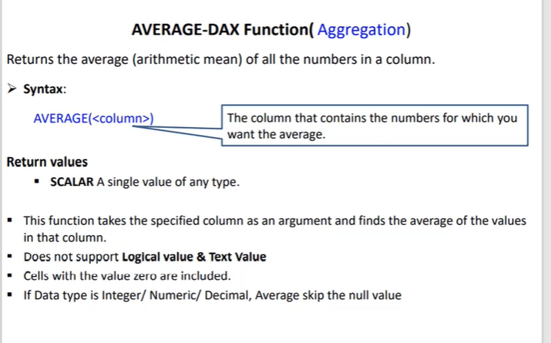

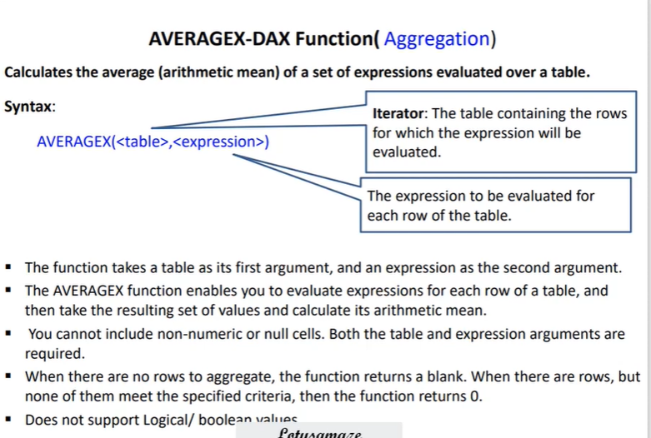

**1]Average:**

**Average Country = AVERAGE('Sales Summary'[Country])**

**Doesn’t work, get error as :**

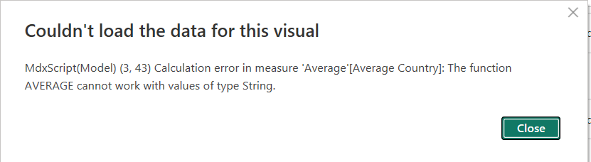

**1] Average QTY Sold = AVERAGE('Sales Summary'[Qty Sold])- works properly**

**2] Average Sales Date = AVERAGE('Sales Summary'[Sales Date]) - works but not an correct way to calculate as it convert dae in numbers and then adds them.**

**3] Average of Boolean = AVERAGE('Sales Summary'[IsActive]) - doesn’t work**

**Doesn’t work, get error as :** 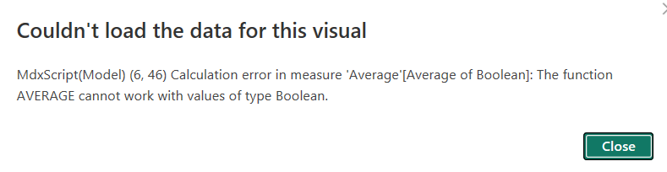

**2] AverageA**

**1] AverageA Country = AVERAGEA('Sales Summary'[Country])- answer is 0**

**2] AverageA QTy Sold = AVERAGEA('Sales Summary'[Qty Sold]) - correct answer**

**3] AverageA Dates = AVERAGEA('Sales Summary'[Sales Date]) - same as average**

**4] AverageA of Boolean = AVERAGEA('Sales Summary'[IsActive]) - count all 1’s and then divide by total rows**

**2] AverageX**

**1] AverageX Qty Sold for Canada = AVERAGEX(FILTER('Sales Summary','Sales Summary'[Country] = "Canada"), 'Sales Summary'[Qty Sold])**

**2] AverageX Qty Sold for Mouse = AVERAGEX(FILTER('Sales Summary','Sales Summary'[Product] = "Mouse"), 'Sales Summary'[Qty Sold])**

**15] Related vs Relatedtable**

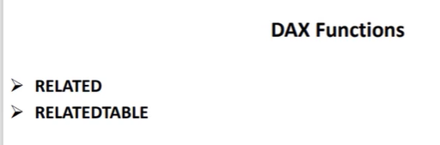

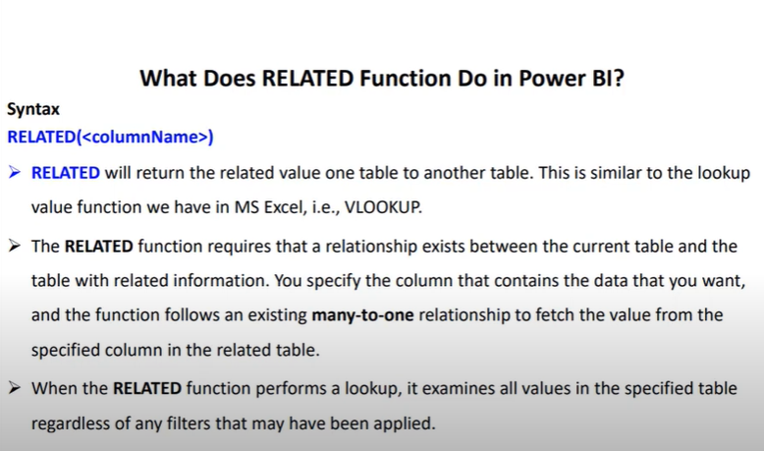

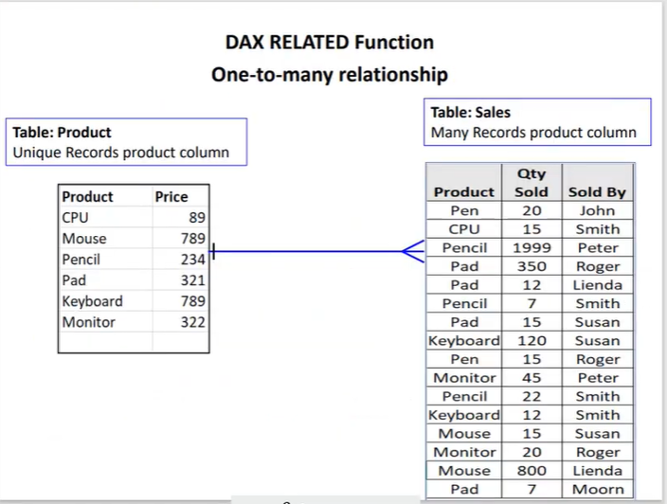

**Total Sales = 'Sales Summary'[Qty Sold] * RELATED('Product'[Price])**

**Price = RELATED('Product'[Price])**

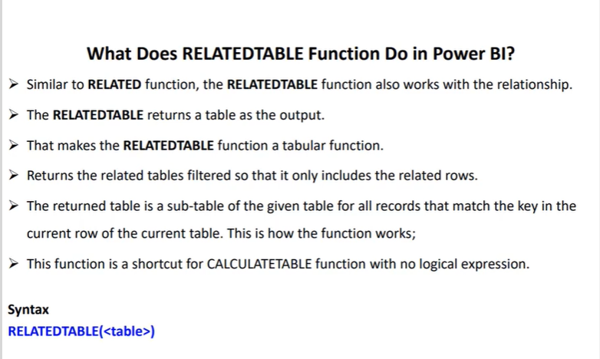

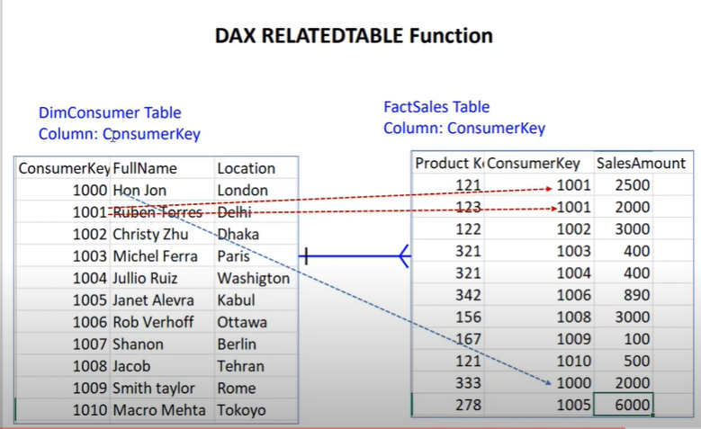

**Total Sales = SUMX(RELATEDTABLE(FactSales),FactSales[SalesAmount])**

**16] DateDiff**

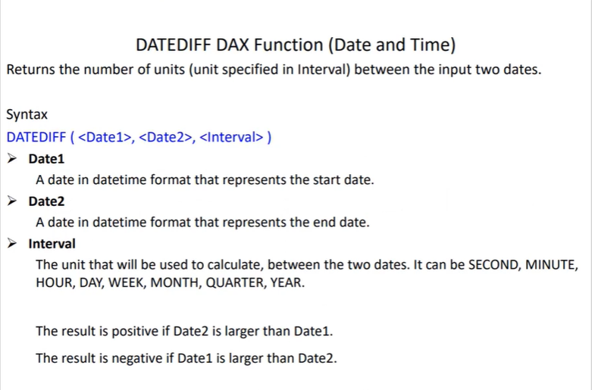

**Age = DATEDIFF('Sales Summary'[BirthDate], TODAY(), YEAR)**

**Service Period = DATEDIFF('Sales Summary'[Joining Date],TODAY(),YEAR)**

**Bonus Eligibility = IF(DATEDIFF('Sales Summary'[Joining Date],TODAY(),YEAR)>4,"Eligible","Not Eligible")**

**16.1] DatesBetween vs DatesInPeriod**

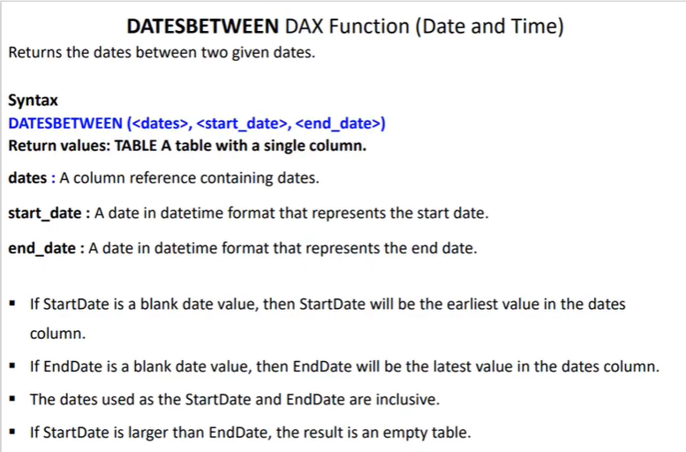

**QTY Sold for Sept = CALCULATE(SUM('Sales Summary'[Qty Sold]), DATESBETWEEN('Sales Summary'[Sales Date],DATE(2019,9,1),DATE(2019,9,30)))**

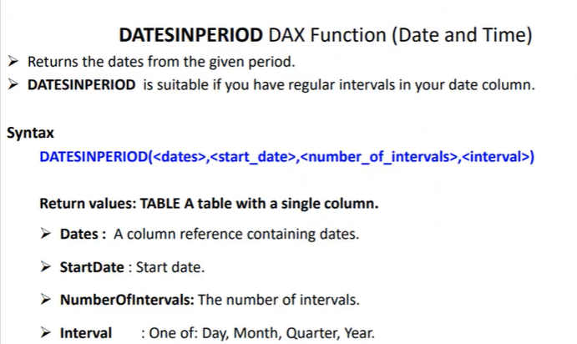

**1] Qty sold for first 15 day of sep = CALCULATE(SUM('Sales Summary'[Qty Sold]),DATESINPERIOD('Sales Summary'[Sales Date],DATE(2019,9,1),15,DAY)**

**2] Qty sold for month of sep = CALCULATE(SUM('Sales Summary'[Qty Sold]),DATESINPERIOD('Sales Summary'[Sales Date],DATE(2019,9,1),1,MONTH))**

**3] Qty sold for Whole Year = CALCULATE(SUM('Sales Summary'[Qty Sold]),DATESINPERIOD('Sales Summary'[Sales Date],DATE(2019,9,1),1,YEAR))**

**4] Similar for Quarter.**

**16.2]Datesmtd Vs Datesqtd Vs Datesytd**

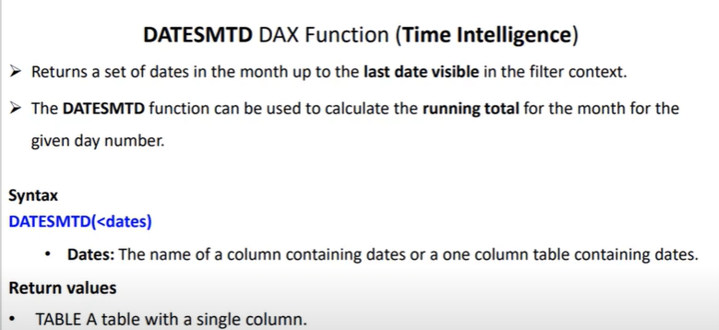

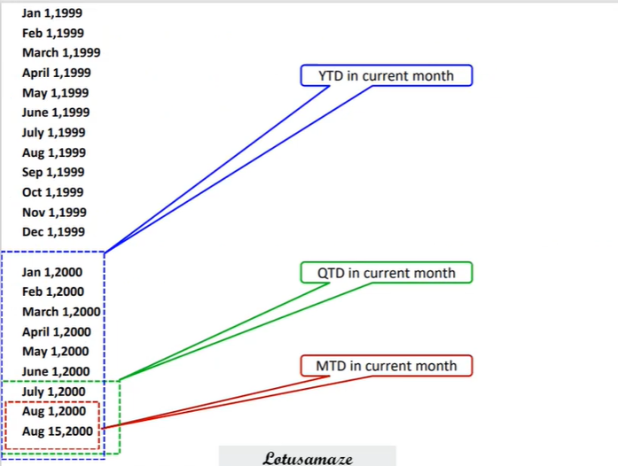

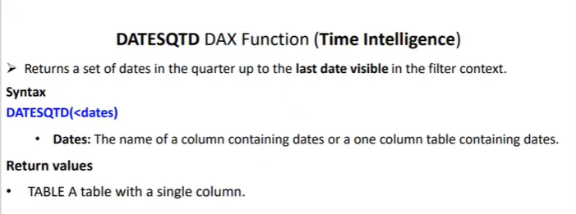

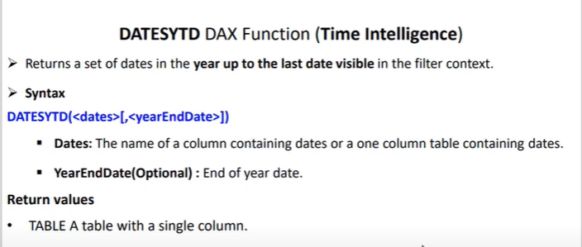

**1] DateMTD = CALCULATE(SUM('Sales Summary'[Qty Sold]),DATESMTD('Sales Summary'[Sales Date])) - Calculates for Last visible month like(dec 2020)**

**2] DateQTD = CALCULATE(SUM('Sales Summary'[Qty Sold]),DATESQTD('Sales Summary'[Sales Date])) - Calculates for Last visible quarter like(oct, nov, dec 2020)**

**3] DateYTD = CALCULATE(SUM('Sales Summary'[Qty Sold]),DATESYTD('Sales Summary'[Sales Date]))- Calculates for Last visible Year like(2020)**

**16.3] Endofmonth, Endofquarter And Endofyear**

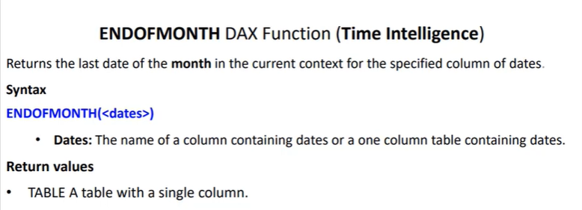

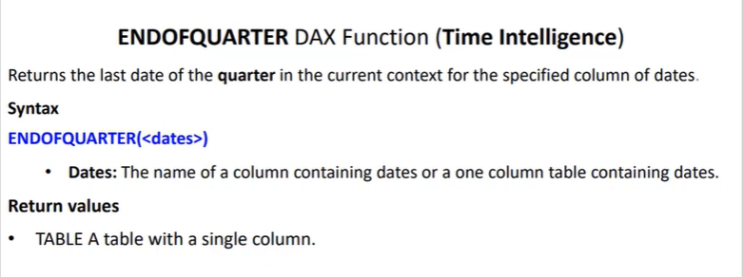

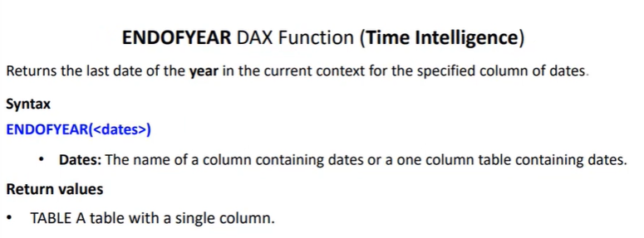

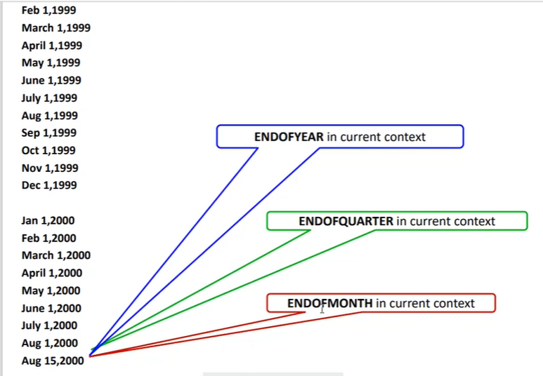

**All Measures will be calculated for date which is at last in data like 19 dec 2022**

**1] QTY Sold for ENDOFMONTH = CALCULATE(SUM('Country (Sales Summary)'[Qty Sold]),ENDOFMONTH('Country (Sales Summary)'[Sales Date])**

**2] QTY Sold for ENDOFQUARTER = CALCULATE(SUM('Country (Sales Summary)'[Qty Sold]),ENDOFQUARTER('Country (Sales Summary)'[Sales Date]))**

**3] QTY Sold for ENDOFYEAR = CALCULATE(SUM('Country (Sales Summary)'[Qty Sold]),ENDOFYEAR('Country (Sales Summary)'[Sales Date]))**

**16.4] TotalMTD, TotalQTD, TotalYTD**

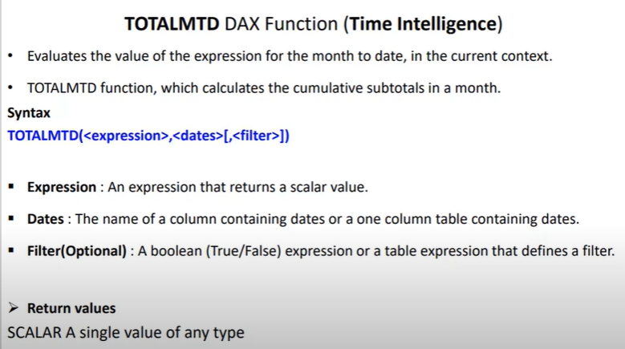

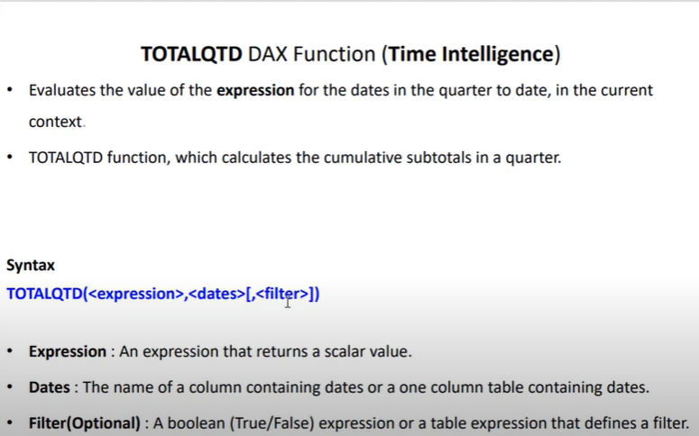

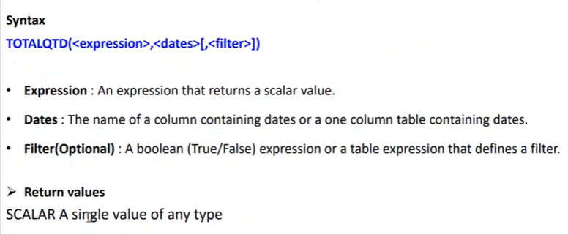

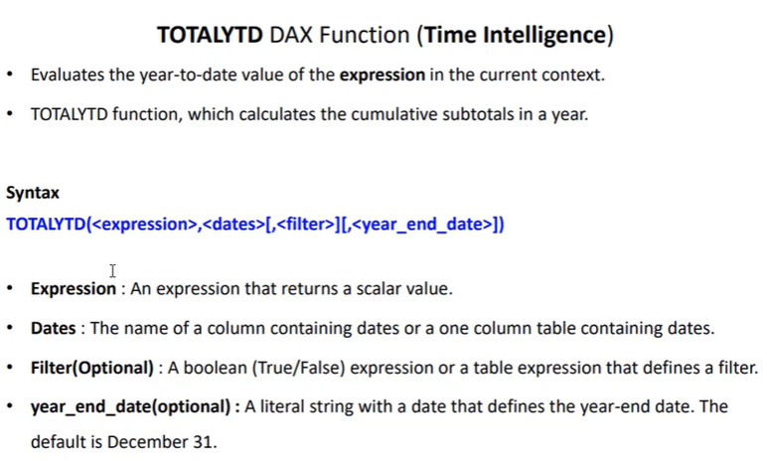

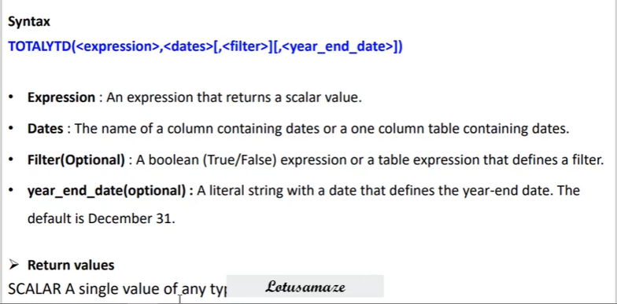

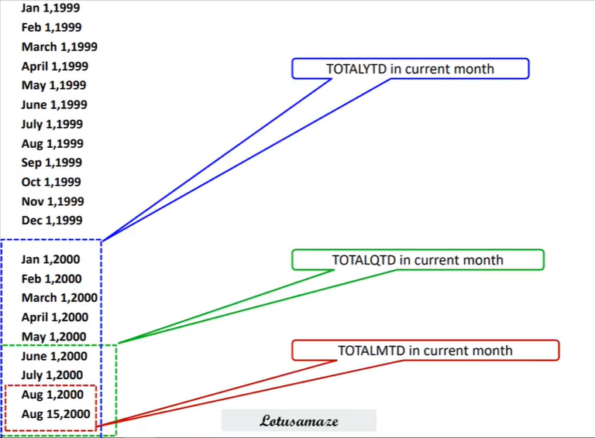

**1] Total_MTD for QTY Sold = TOTALMTD(SUM('Country (Sales Summary)'[Qty Sold]),'Country (Sales Summary)'[Sales Date])**

**2] Total_MTD-QTY Sold(Pen) = TOTALMTD(SUM('Country (Sales Summary)'[Qty Sold]),'Country (Sales Summary)'[Sales Date], 'Country (Sales Summary)'[Product] = "Pen")**

**3] Total_QTD for QTY Sold = TOTALQTD(SUM('Country (Sales Summary)'[Qty Sold]),'Country (Sales Summary)'[Sales Date])**

**4] Total_QTD-QTY Sold(Mouse) = TOTALQTD(SUM('Country (Sales Summary)'[Qty Sold]),'Country (Sales Summary)'[Sales Date], 'Country (Sales Summary)'[Product] = "Mouse")**

**5] Total_YTD for QTY Sold = TOTALYTD(SUM('Country (Sales Summary)'[Qty Sold]),'Country (Sales Summary)'[Sales Date])**

**6] Total_YTD-QTY Sold(Pencil) = TOTALYTD(SUM('Country (Sales Summary)'[Qty Sold]),'Country (Sales Summary)'[Sales Date], 'Country (Sales Summary)'[Product] = "Pencil")**

**7] Total_YTD-QTY Sold(Pencil) for march = TOTALYTD(SUM('Country (Sales Summary)'[Qty Sold]),'Country (Sales Summary)'[Sales Date], 'Country (Sales Summary)'[Product] = "Pencil","3/31")**

**17] CrossJoin**

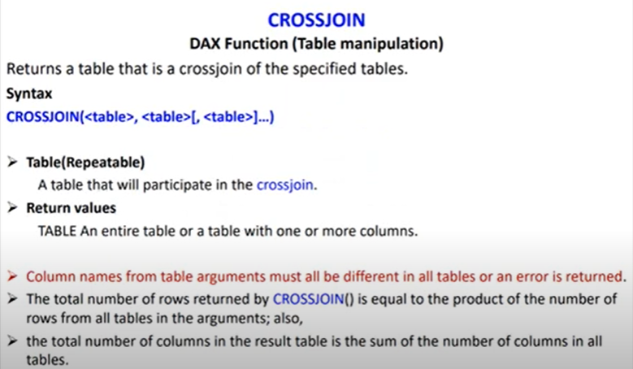

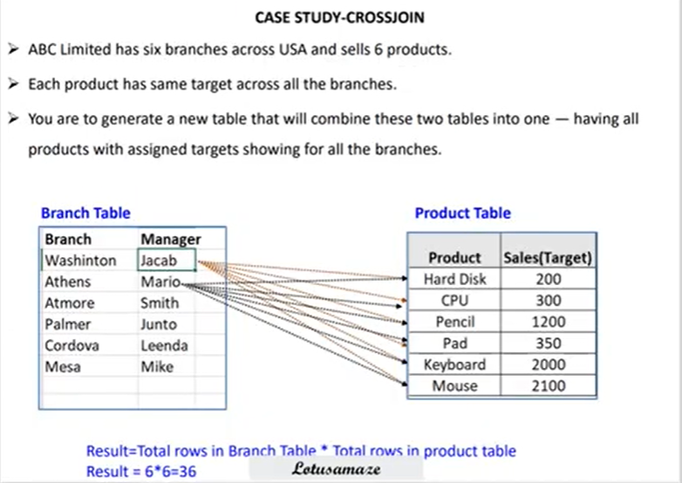

**1] Branch and Product = CROSSJOIN('Branch Table','Product Table') - Total rows after execution 36(6*6).**

**2] Branch Product and Category = CROSSJOIN('Branch Table','Product Table','Category') - Total rows after execution 72(36*2).**

**18] Union, Intersect and Except(Table Manipulation)**

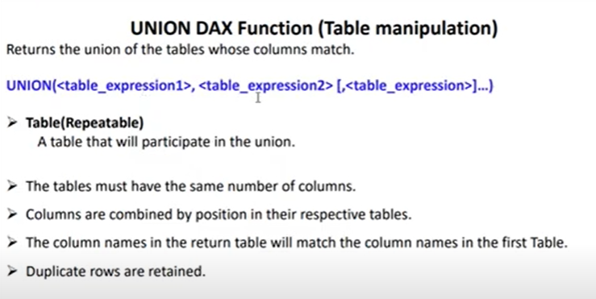

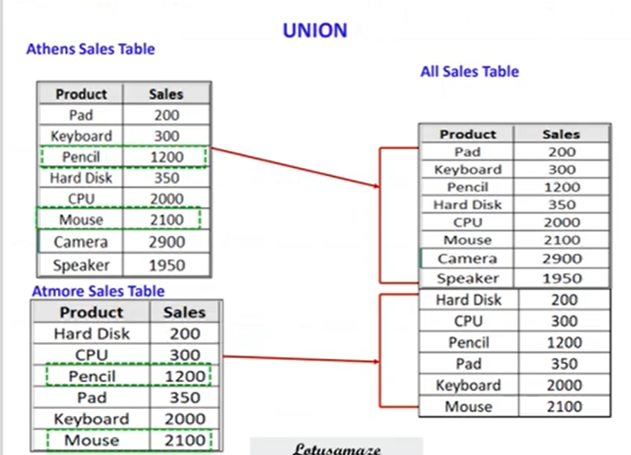

**Union of Tables = UNION('Athens Sales','Atmore Sales')**

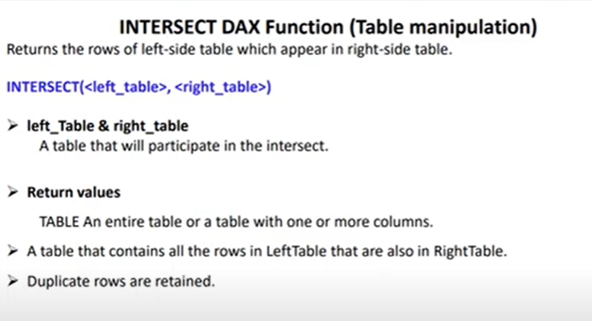

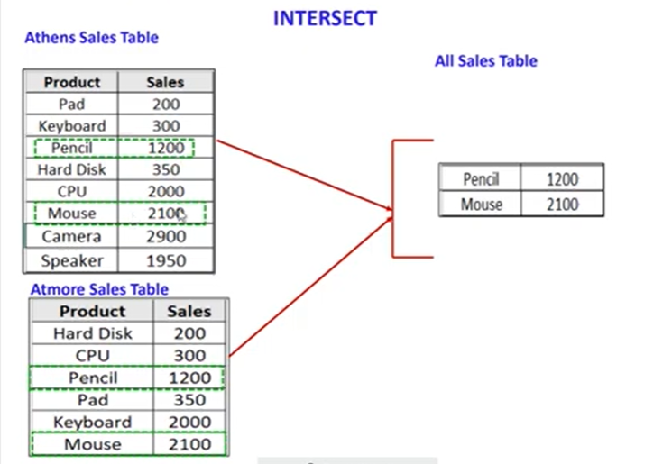

**Intersect of Tables = INTERSECT('Athens Sales','Atmore Sales')**

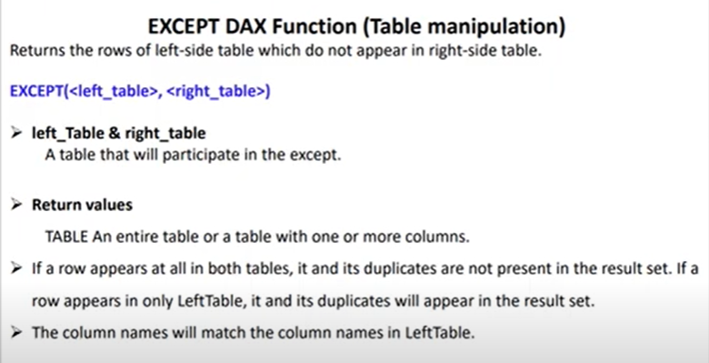

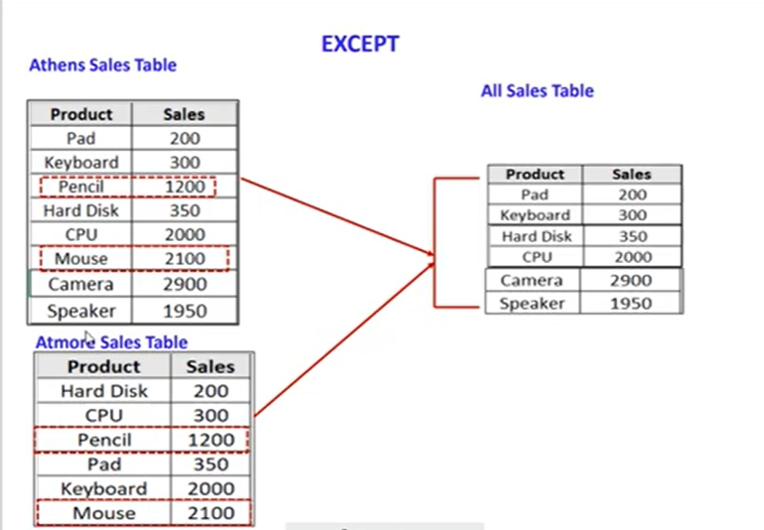

**Except of Tables = EXCEPT('Athens Sales','Atmore Sales')**

**19] Coalesce(Logical)**

**Sample:**

**1] One Blank = COALESCE(Blank(), 10,20) - answer is 10**

**2] Two Blank = COALESCE(Blank(), Blank(), "Shivam", "Patil") - answer is Shivam**

**3] All Blank = COALESCE(BLANK(),BLANK(),BLANK(),BLANK())-answer is Blank**

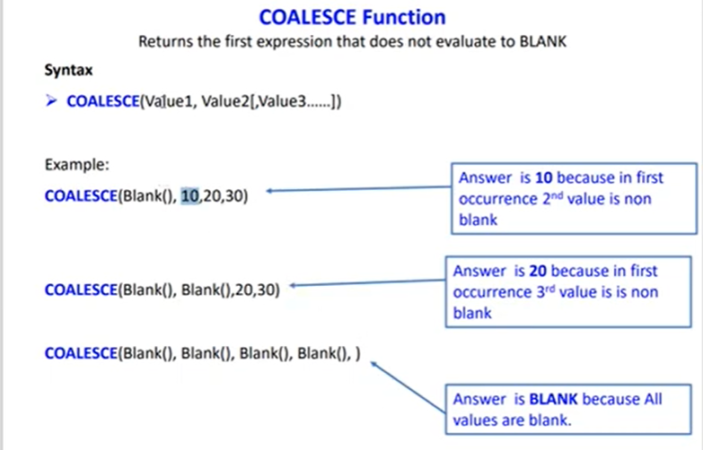

**1] New Product = COALESCE('Sales Summary'[Product],"Key Board")**

**2] New Sales Date = COALESCE('Sales Summary'[Sales Date],TODAY())**

**3] New Net Sales = COALESCE('Sales Summary'[Net Sales],0)**

**20] Switch(Logical)**

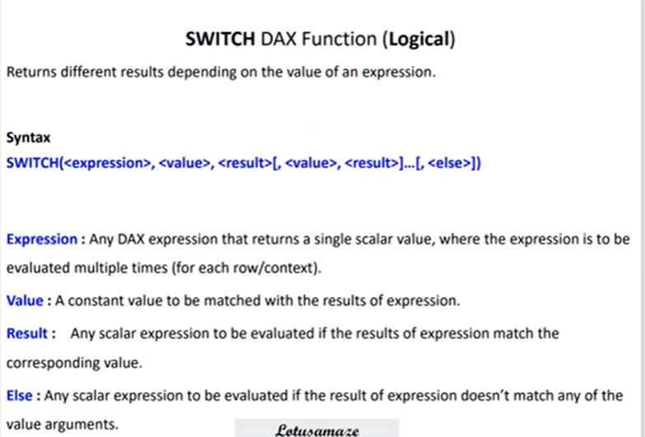

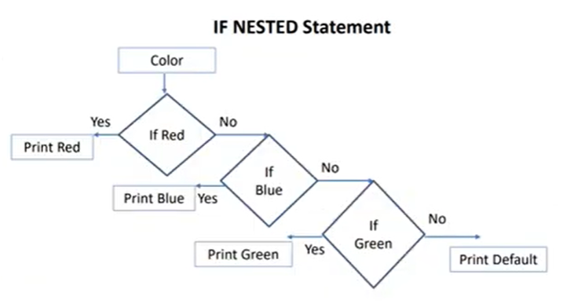

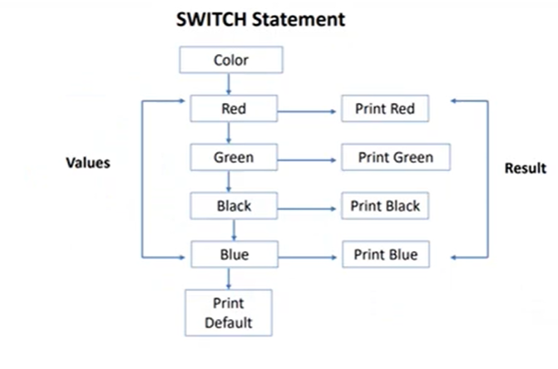

**Country Code = SWITCH('Sales Summary'[Country],"Canada", "CA","France","FR", "Germany","Ge","Defalut Code")**

**21] RankX(Statistical)**

**New Columns Created:**

**With Skip:**

**RankX for Net sales with Skip = RANKX('Sales Summary','Sales Summary'[Net Sales],,DESC,Skip)**

**With Dense:**

**RankX for Net sales with Dense = RANKX('Sales Summary','Sales Summary'[Net Sales],,DESC,Dense)**

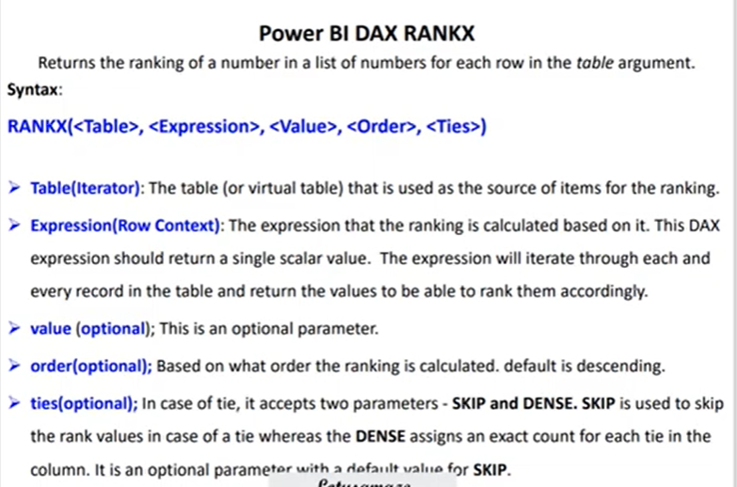

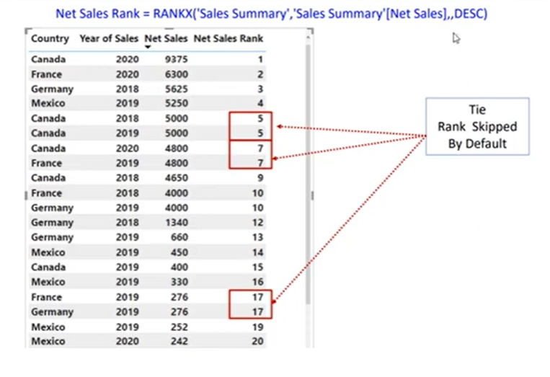

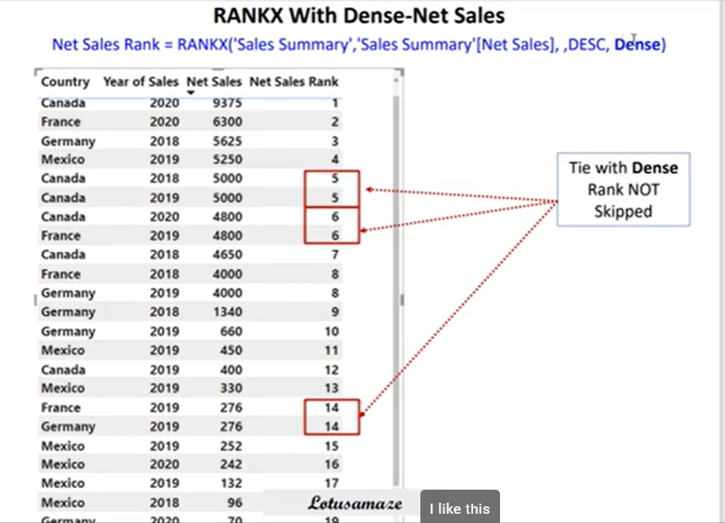

**New Measures Created:**

**1] Due to Filter on Country it will give 1 ranking to all countries as shown in below snapshot.**

**RankX_Measure1 = RANKX('Sales Summary',SUM('Sales Summary'[Net Sales]),,)**

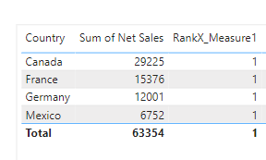

**2] Now we remove all filters on Country using ALL() and then we get the following result.**

**RankX_Measure2 = RANKX(ALL('Sales Summary'[Country]),'Sales Summary'[Sum_NetSales],,)**

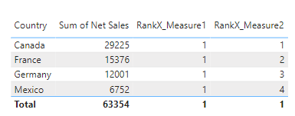

**2] Now again when we add Products in table, rankings gets misjumbled like below screenshot and then again we add Products in All() like below and update RankX_Measure2 like this:**

**RankX_Measure2 = RANKX(ALL('Sales Summary'[Country],'Sales Summary'[Product]),'Sales Summary'[Sum_NetSales],,)**

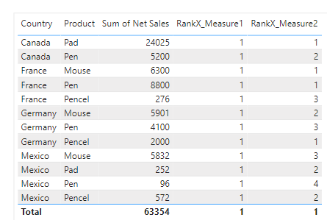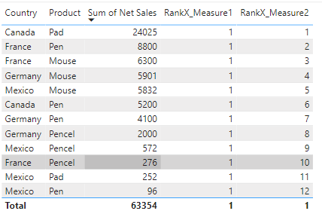

**22] TopN, Dynamic TopN(Table Manipulation)**

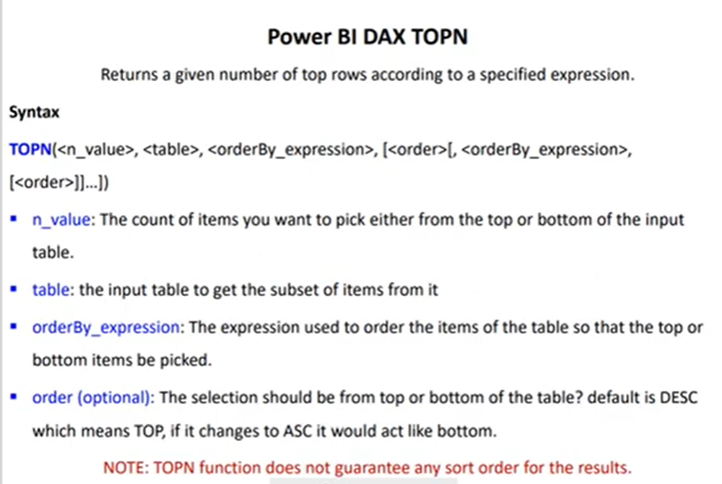

**Table Creation**

**1] Top_5_QTY Sold = TOPN(5,'Sales Summary')**

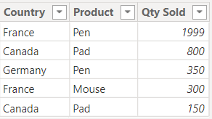

**2] Top_5_QTY Sold = TOPN(5,'Sales Summary', 'Sales Summary'[Qty Sold])**

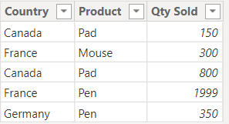

**3] Top_5_QTY Sold = TOPN(5,'Sales Summary', 'Sales Summary'[Qty Sold],ASC)**

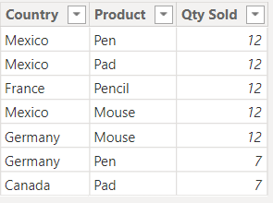

Ties in the Sorted Column: When you use the "asc" parameter to sort the data in ascending order, if there are tied values in the column you're sorting by, DAX may return all tied values. In your case, you have the value "12" occurring multiple times and the value "7" occurring multiple times. DAX may include all the tied values in the result set, resulting in more rows than you expected.

To address this and get only the distinct bottom 5 values, you may need to apply additional filtering or use a different DAX expression. You can use a combination of functions like SUMMARIZE and TOPN to get the distinct values before applying the "asc" sorting and then retrieve the bottom 5.

**3] Top_5_QTY Sold = TOPN(5,'Sales Summary', 'Sales Summary'[Product])**

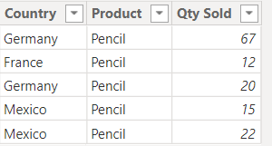

**Measure Creation**

**1]Top_5_QTY SOld by sum = CALCULATE(SUM('Sales Summary'[Qty Sold]),TOPN(2,'Sales Summary','Sales Summary'[Qty Sold]))**

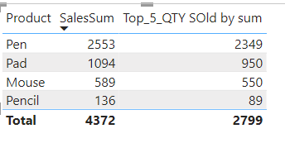

**Why Such Difference????**

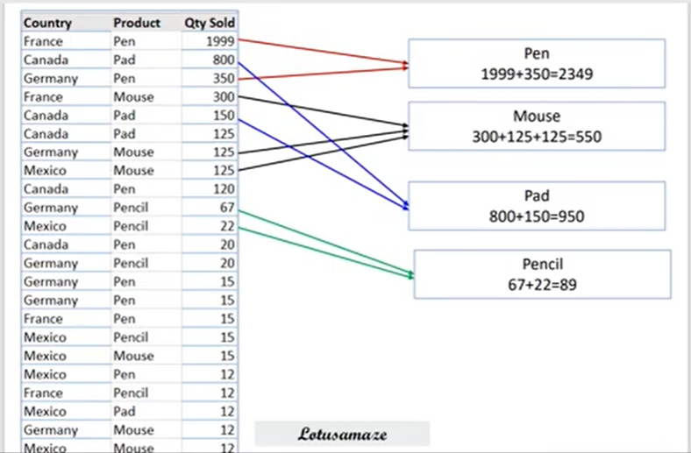

**Dynamic Top N**

**1] First Create one table with 5 values in it as 1,2,3 4,5 and then create one measure as below.**

**Dynamic Measure = var setValue = SELECTEDVALUE(Numbers_table[Column1])**

**RETURN**

**CALCULATE(SUM('Sales Summary'[Qty Sold]),TOPN(setValue,'Sales Summary','Sales Summary'[Qty Sold]))**

**2] Drop this newly created measure in the table but it will show blank as we haven’t passed the value through the slicer.**

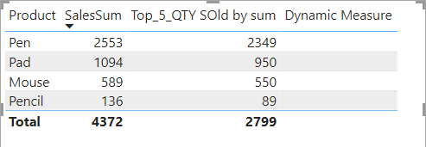

**3] When we use slicer we will get result as:**

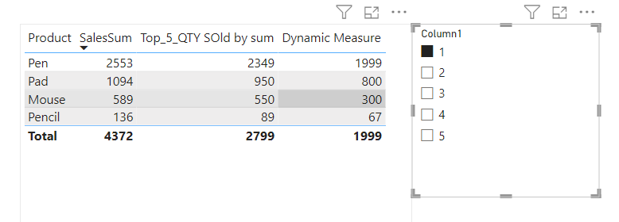

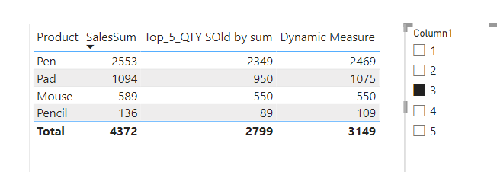

**23] DAX - TreatAS(Table Manipulation)**

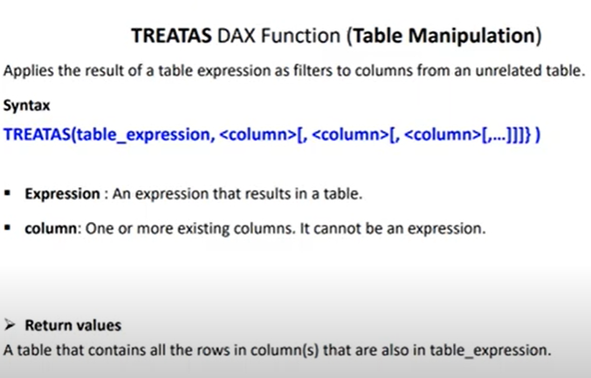

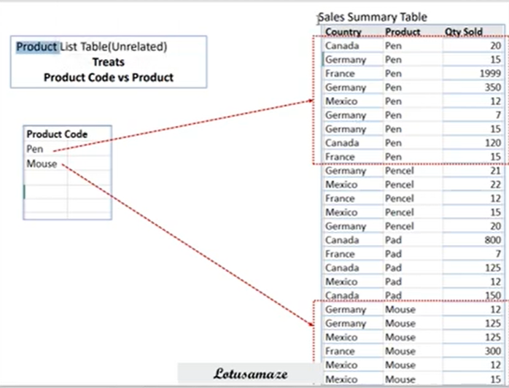

**1] TreatAS_Measure = CALCULATE(SUM('Sales Summary'[Qty Sold]),TREATAS(VALUES('Product List'[Product Code]),'Sales Summary'[Product])**

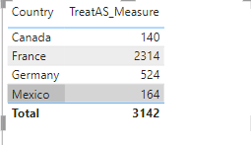

**24] DAX - Earlier**

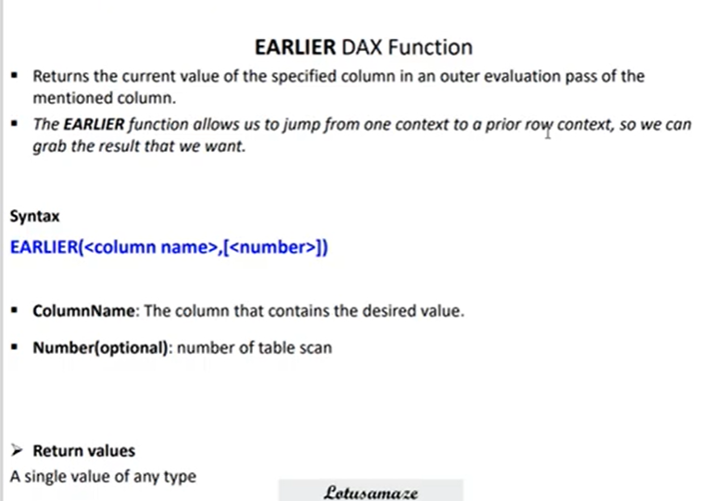

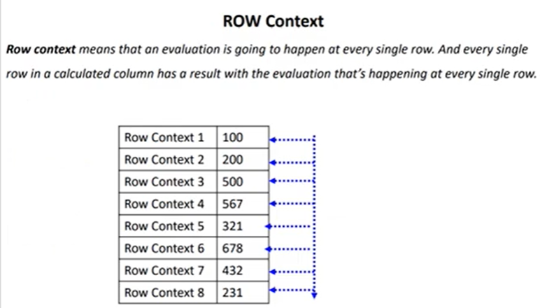

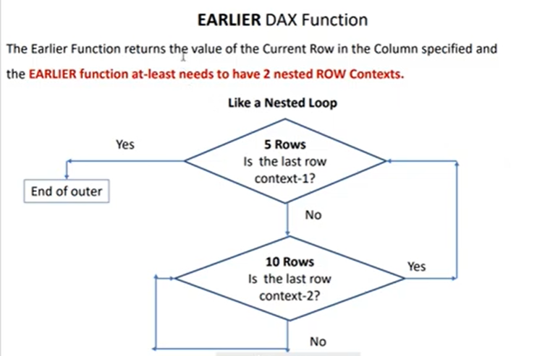

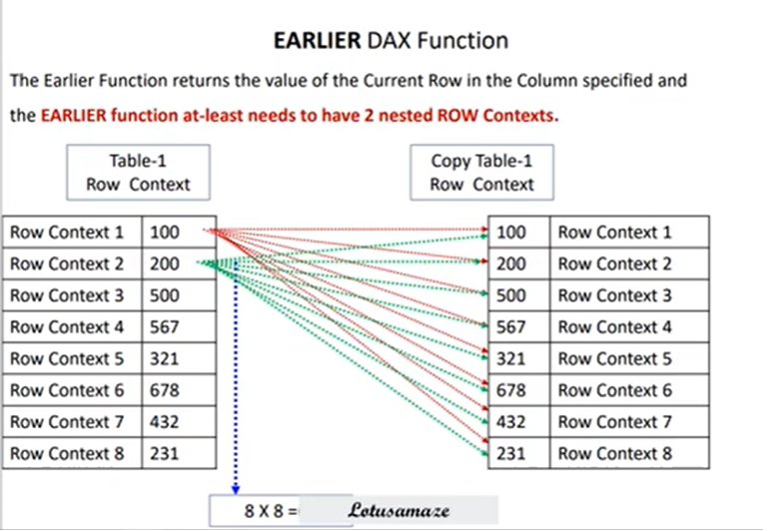

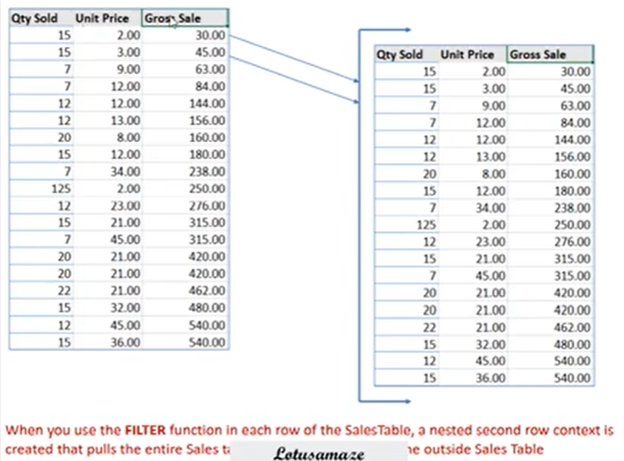

**1] Cumulative Gross Sale Sum = CALCULATE(SUM('Sales Summary'[Gross Sale]),**

**FILTER('Sales Summary','Sales Summary'[Gross Sale] <= EARLIER('Sales Summary'[Gross Sale])))**

**2] Count Row = COUNTROWS(FILTER('Sales Summary','Sales Summary'[Gross Sale] <= EARLIER('Sales Summary'[Gross Sale])))**

**25] SelectedColumns vs AddColumns(Table Manipulation)**

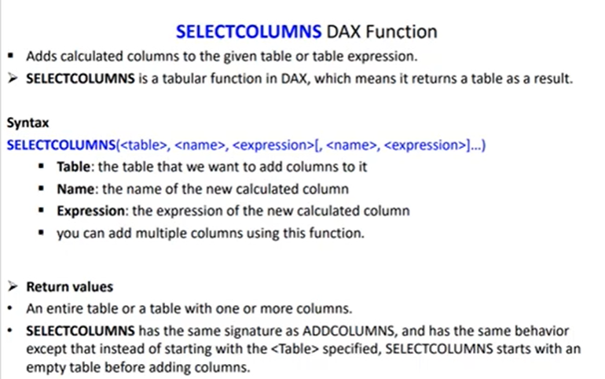

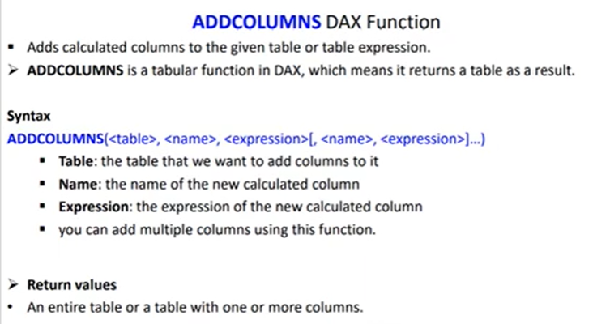

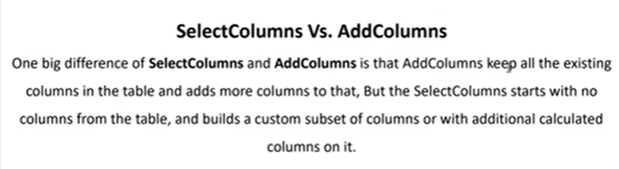

**1] For SelectColumns we have to create new table and then run this formula**

**SelectedColumns Sample = SELECTCOLUMNS('Sales Summary',**

**"Country",'Sales Summary'[Country],**

**"Product", 'Sales Summary'[Product],**

**"Unit Price",'Sales Summary'[Unit Price],**

**"QTY Sold",'Sales Summary'[Qty Sold],**

**"Total Sales",CALCULATE(SUM('Sales Summary'[Unit Price]) * SUM('Sales Summary'[Qty Sold])))**

**2] AddColumns append columns in existing table**

**AddColumns = ADDCOLUMNS('Sales Summary',**

**"Total Sales",CALCULATE(SUM('Sales Summary'[Unit Price]) * SUM('Sales Summary'[Qty Sold])))**

**26] DAX - Filter(Filter)**

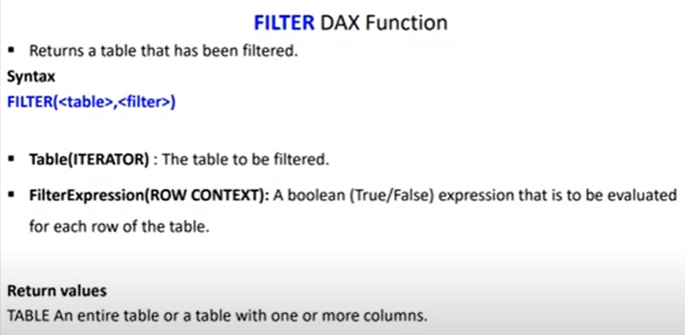

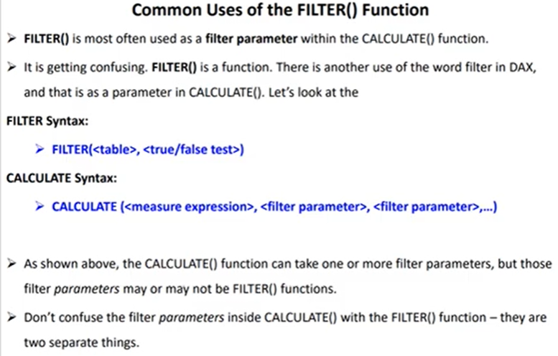

**1] Table1 Filter = FILTER('Sales Summary','Sales Summary'[Country]="Canada")**

**2] Table2 Filter = FILTER('Sales Summary','Sales Summary'[Product]="Pen")**

**3] Table2 Filter = FILTER('Sales Summary',AND('Sales Summary'[Product]="Pen", 'Sales Summary'[Country]="Canada"))**

**4] Total Canada = COUNTROWS(FILTER('Sales Summary','Sales Summary'[Country] = "Canada"))**

**5] Total Canada Sales = CALCULATE(SUM('Sales Summary'[Qty Sold]),FILTER('Sales Summary','Sales Summary'[Country] = "Canada"))**

**27] Row Context VS Filter Context**

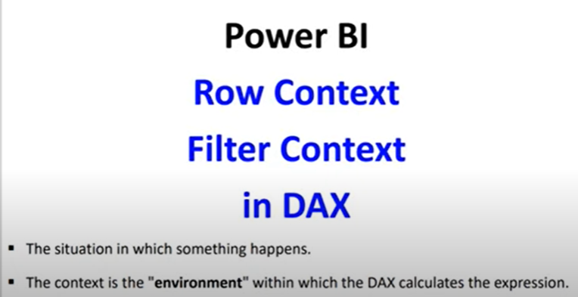

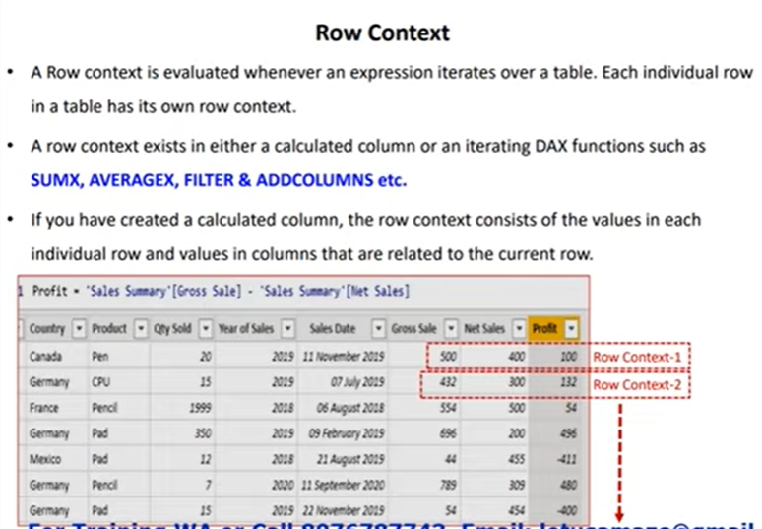

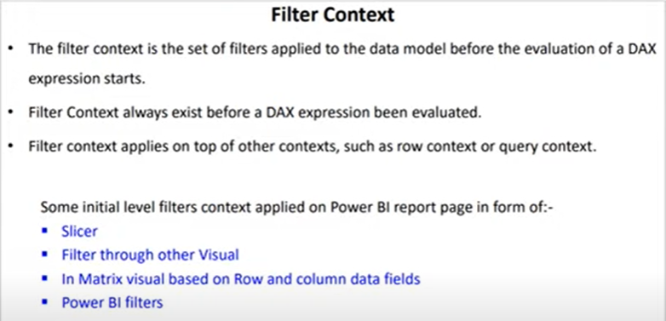

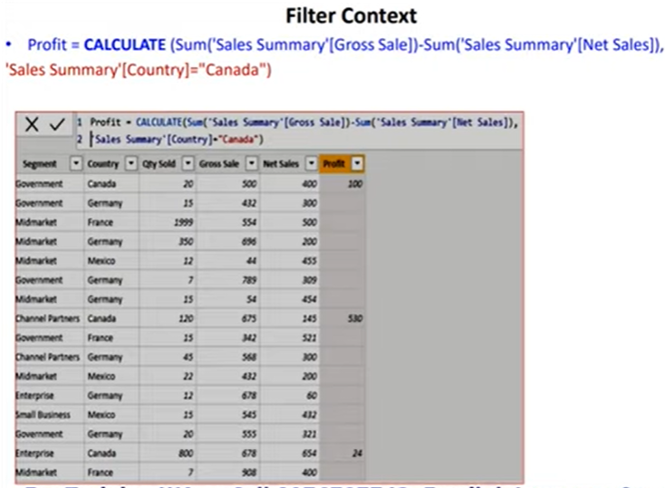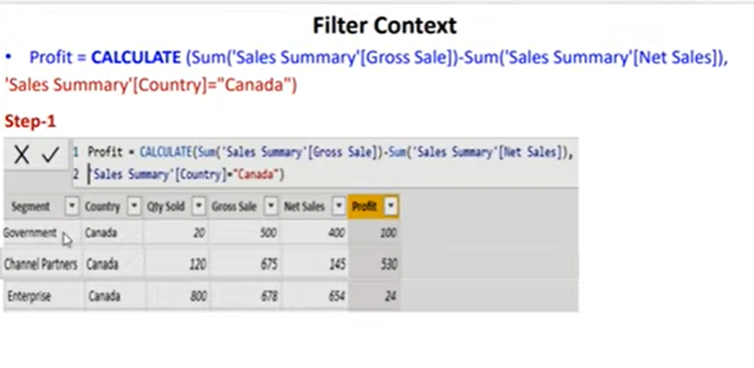

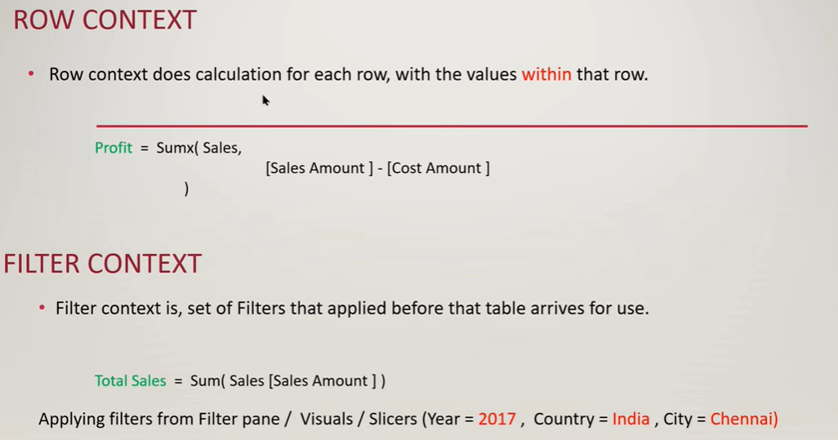

**28] DAX - SamePeriodLastYear**

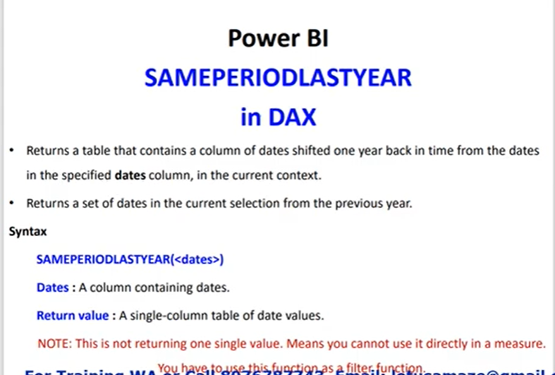

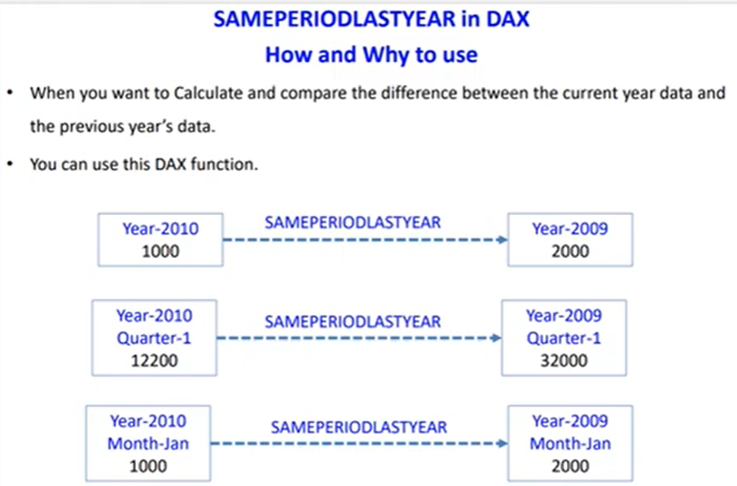

**Gross Sale Previous Year = CALCULATE([Total Gross Sale], SAMEPERIODLASTYEAR('Sales Summary'[Sales Date].[Date]))**

**29] DAX - ParallelPeriod(Context Transition)**

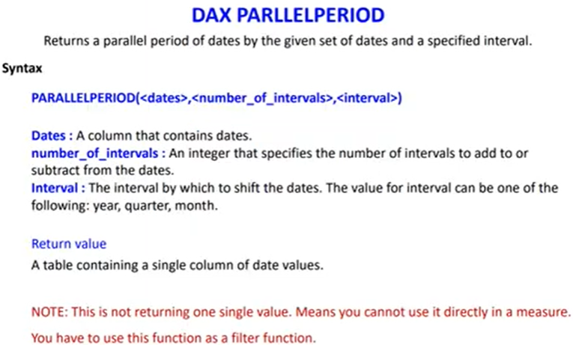

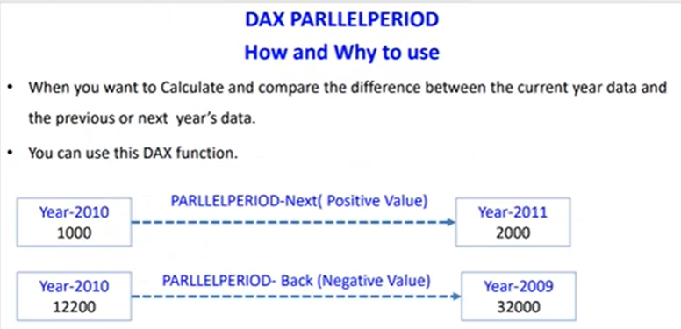

**1] ParallelPeriod Sales = CALCULATE('Sales Summary'[Total Gross Sale],PARALLELPERIOD('Sales Summary'[Sales Date].[Date],1,YEAR))**

**2] ParallelPeriod Sales = CALCULATE('Sales Summary'[Total Gross Sale],PARALLELPERIOD('Sales Summary'[Sales Date].[Date],-1,YEAR))**

**3] ParallelPeriod Sales = CALCULATE('Sales Summary'[Total Gross Sale],PARALLELPERIOD('Sales Summary'[Sales Date].[Date],2,YEAR))**

**30] DAX - Variables**

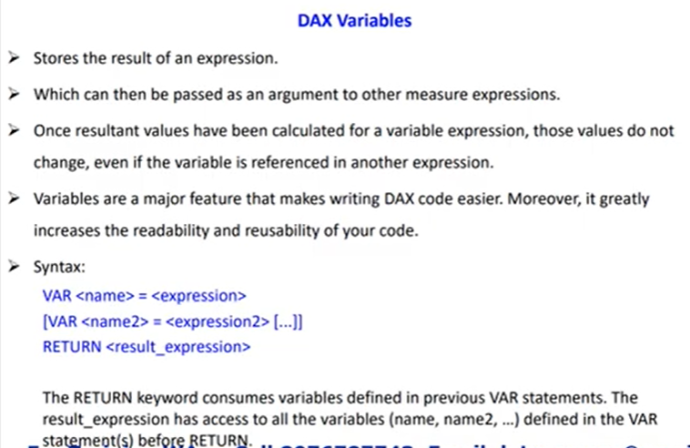

**1] Country Name with Var =**

**var canadaSales = CALCULATE(SUM('Sales Summary'[Gross Sale]),'Sales Summary'[Country] = "Canada")**

**var germanySales = CALCULATE(SUM('Sales Summary'[Gross Sale]),'Sales Summary'[Country] = "Germany")**

**var germanyProductsCount = CALCULATE(COUNT('Sales Summary'[Gross Sale]),'Sales Summary'[Country] = "Germany")**

**RETURN**

**IF(canadaSales > germanySales, "Canada:" & canadaSales,"Germany Sales and Product Counts:" & germanySales & "," & germanyProductsCount)**

**2] Country Name with Var =**

**var canadaSales = CALCULATE(SUM('Sales Summary'[Gross Sale]),'Sales Summary'[Country] = "Canada")**

**var germanySales = CALCULATE(SUM('Sales Summary'[Gross Sale]),'Sales Summary'[Country] = "Germany")**

**var germanyProductsCount = CALCULATE(COUNT('Sales Summary'[Gross Sale]),'Sales Summary'[Country] = "Germany")**

**RETURN**

**IF(canadaSales > germanySales, "Canada:" & canadaSales,"Germany:" & germanySales)**

**3] Difference of Sales =**

**var totalSales = SUM('Sales Summary'[Gross Sale])**

**var lastYearSales = CALCULATE(SUM('Sales Summary'[Gross Sale]),SAMEPERIODLASTYEAR('Sales Summary'[Sales Date].[Date]))**

**RETURN**

**totalSales - lastYearSales**

**31] IsFiltered And IsCrossFiltered**

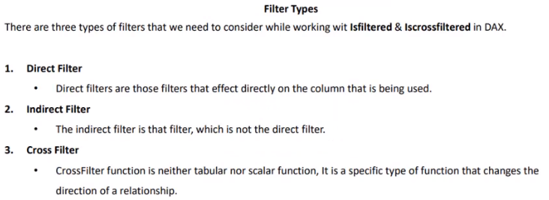

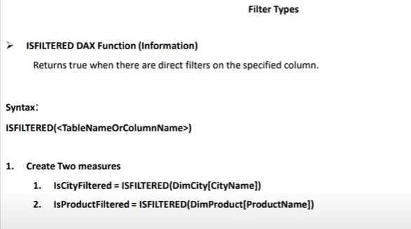

**1] isCityFiltered = ISFILTERED(DimCity[CityName])**

**2] isProductFiltered = ISFILTERED(DimProduct[ProductName])**

**Return True or False only.**

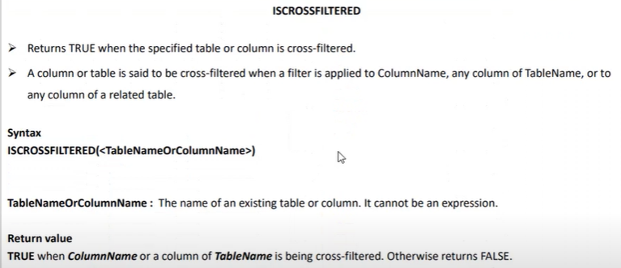

**As you can see there is no relation between Dim City and Fact Reseller.**

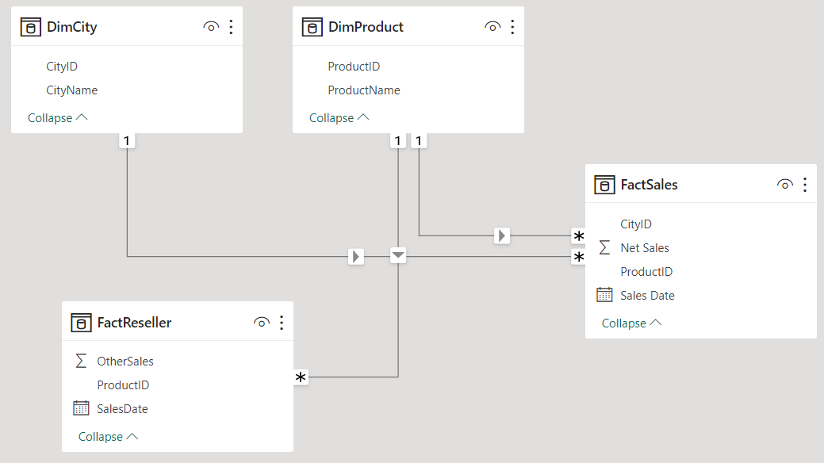

**And when we put CityName from DimCity, Net Sales from FactSales and OtherSales from FactReseller then we don’t get correct sum of Othersalesand also when we put isCrossFiltered measure in table we get false.**

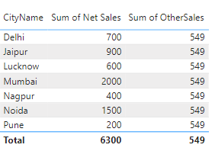

**Now when we go to model View and change cross filter direction between DimProduct and factSales to both we get the following output.**

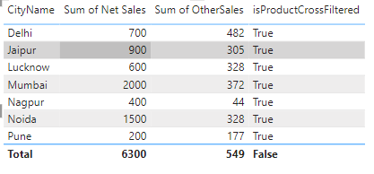

**32] Summarize and SummarizeColumns(Table Manipulation)**

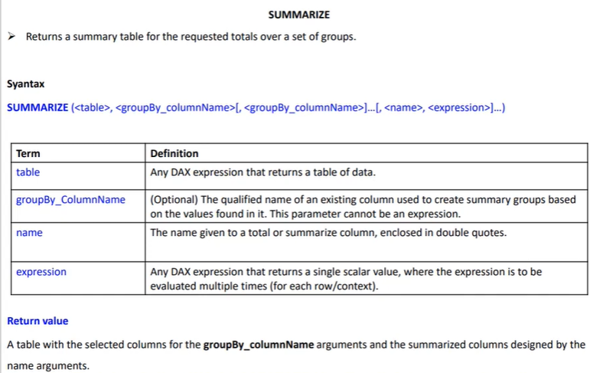

**1] Product Summary Table = SUMMARIZE('Product','Product'[ProductName],"Total Sales",SUM('Product'[Sales]),"Count of Product",COUNT('Product'[Sales]))**

**2] Product Summary Table = SUMMARIZE('Product','Product'[ProductName],ROLLUP('Product'[Color])**

**,"Total Sales",SUM('Product'[Sales]),"Count of Product",COUNT('Product'[Sales]))**

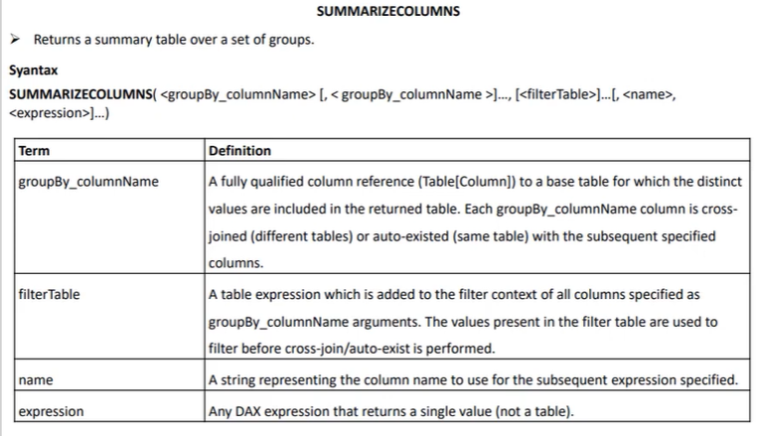

**Return values:**

**TABLE: An entire table or table with one or more columns**

**Product Summary Column = SUMMARIZECOLUMNS(ProductCode[ProductName],FILTER('Product','Product'[Color] = "Red"),"Total Sales",SUM('Product'[Sales]))**

**33] DAX - NetworkDays**

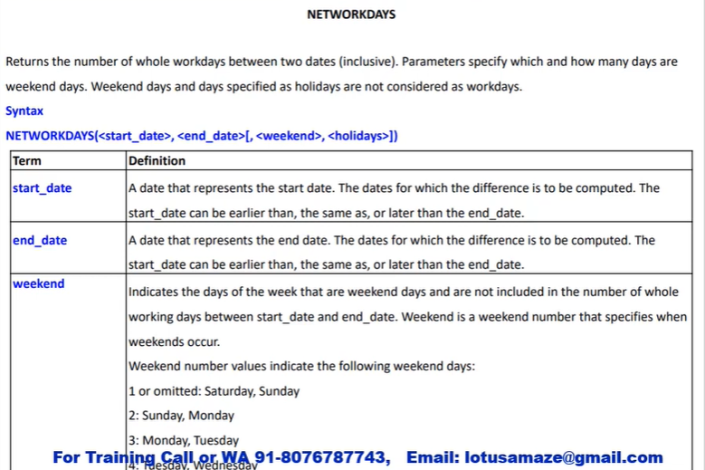

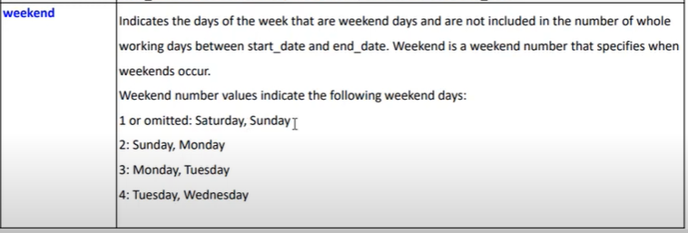

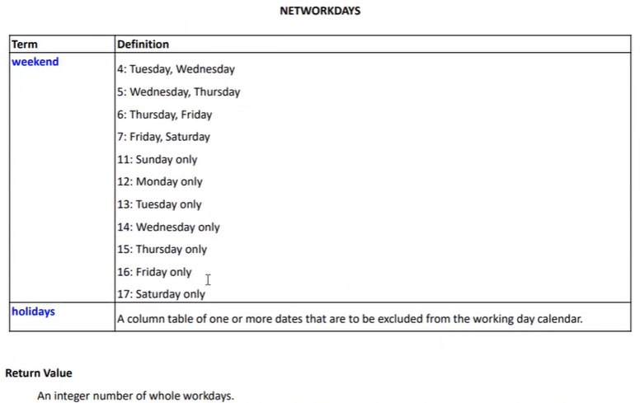

**1] Sample of Net_Work_Days = NETWORKDAYS(DATE(2023,11,01),DATE(2023,11,10),1) - Total Count 8 days without counting holiday on 07-11-2023.**

**2] Sample of Net_Work_Days = NETWORKDAYS(DATE(2023,11,01),DATE(2023,11,10),1,{DATE(2023,11,07)}) - Total Count 7 days with counting holiday on 07-11-2023.**

**3] Employees Net_Work_Days = NETWORKDAYS('Employee Attendance Data'[Attendance From],'Employee Attendance Data'[Attendance To],1) - with sat and sun as weekend.**

**4] Employees Net_Work_Days = NETWORKDAYS('Employee Attendance Data'[Attendance From],'Employee Attendance Data'[Attendance To],11) - with sun as weekend only.**

**5] Employees Net_Work_Days = NETWORKDAYS('Employee Attendance Data'[Attendance From],'Employee Attendance Data'[Attendance To],1, VALUES(Holidays[DATE]))**

**6] Employees Net_Work_Days1 = NETWORKDAYS('Employee Attendance Data'[Attendance From],'Employee Attendance Data'[Attendance To],1)**

**34] Dimension Table, Fact Table, Star Schema**

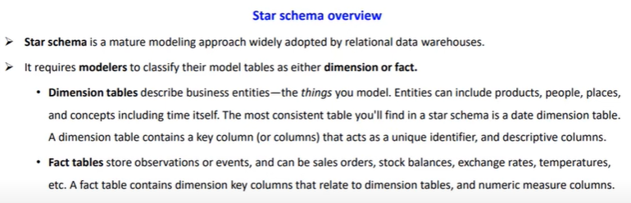

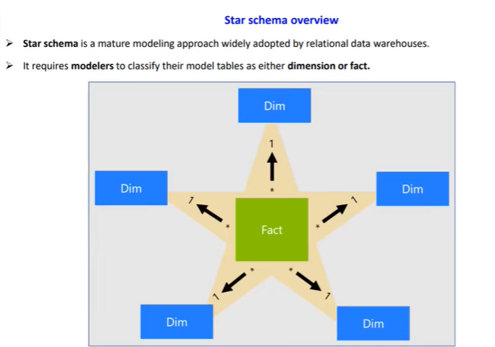

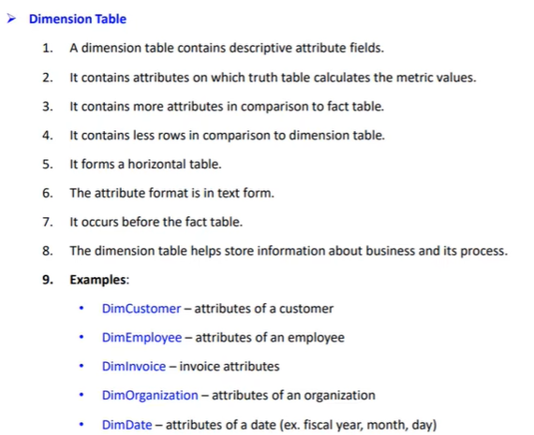

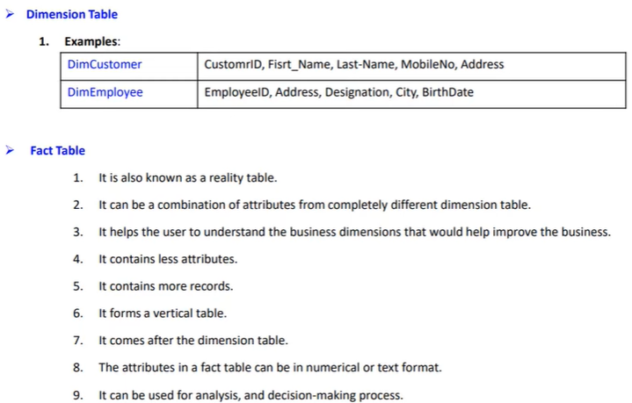

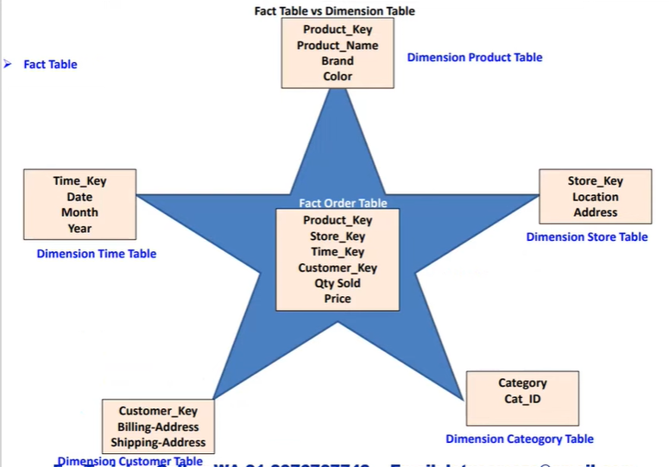

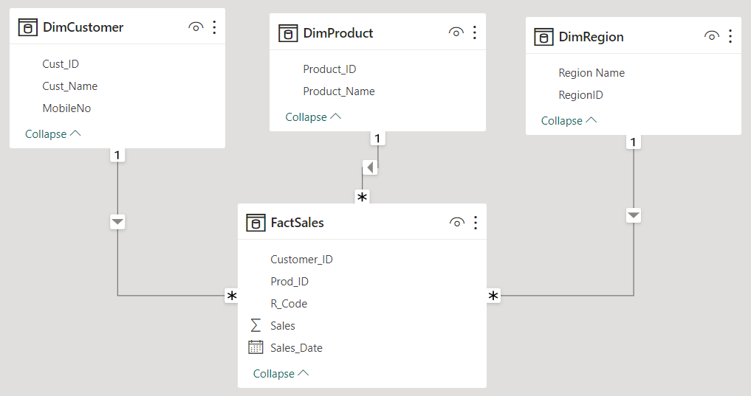

**35] Quick Measure in Power BI(suggestions)**

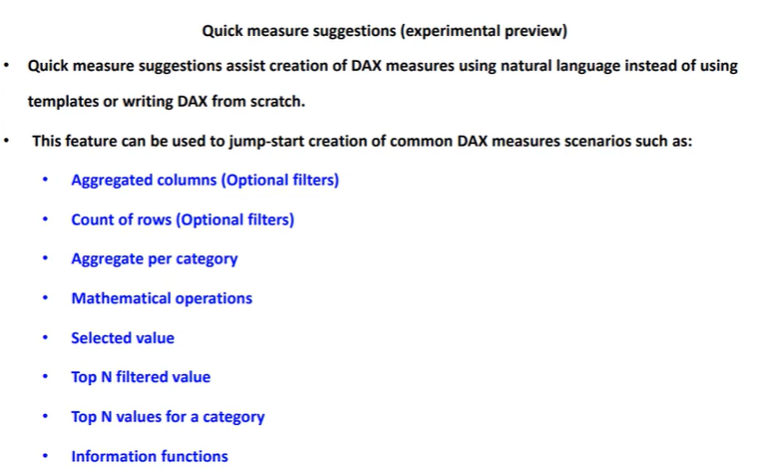

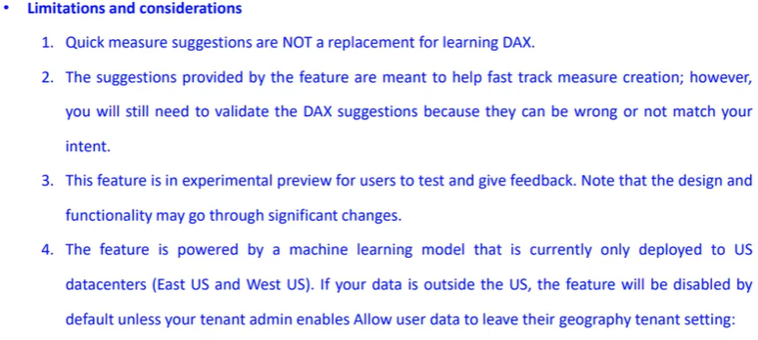

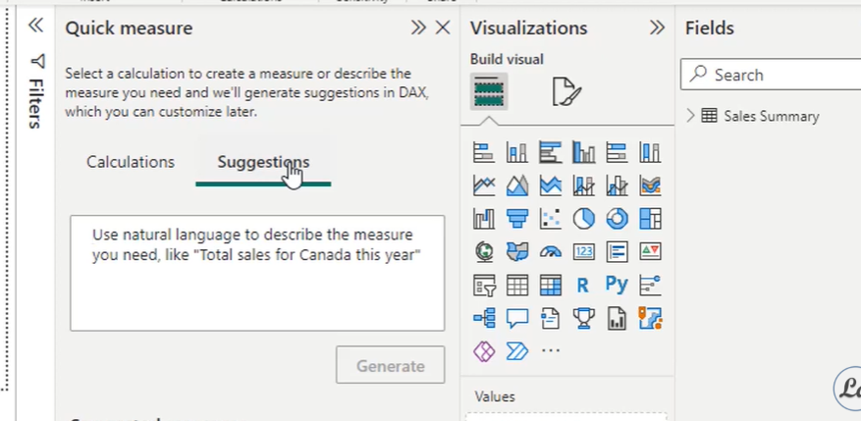

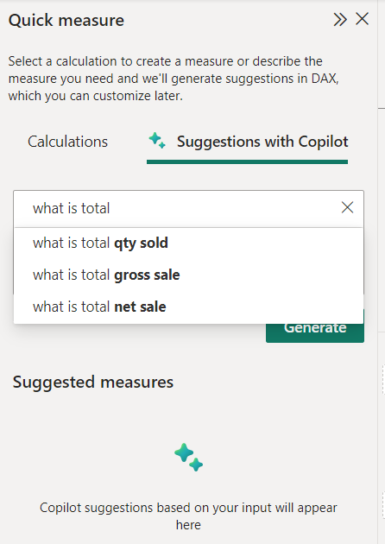 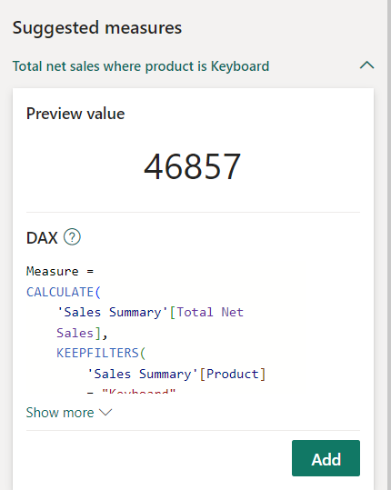

**37] DAX KeepFilters**

Modifies how filters are applied while evaluating a CALCULATE or CALCULATETABLE function.

## Syntax

DAX

Copy

KEEPFILTERS(<expression>)

### Parameters

| Term | Definition |
| --- | --- |
| expression | Any expression. |

## Return value

A table of values.

## Remarks

* You use KEEPFILTERS within the context CALCULATE and CALCULATETABLE functions, to override the standard behavior of those functions.
* By default, filter arguments in functions such as CALCULATE are used as the context for evaluating the expression, and as such filter arguments for CALCULATE replace all existing filters over the same columns. The new context effected by the filter argument for CALCULATE affects only existing filters on columns mentioned as part of the filter argument. Filters on columns other than those mentioned in the arguments of CALCULATE or other related functions remain in effect and unaltered.
* The KEEPFILTERS function allows you to modify this behavior. When you use KEEPFILTERS, any existing filters in the current context are compared with the columns in the filter arguments, and the intersection of those arguments is used as the context for evaluating the expression. The net effect over any one column is that both sets of arguments apply: both the filter arguments used in CALCULATE and the filters in the arguments of the KEEPFILTER function. In other words, whereas CALCULATE filters replace the current context, KEEPFILTERS adds filters to the current context.
* This function is not supported for use in DirectQuery mode when used in calculated columns or row-level security (RLS) rules.

**Formal Sales with KF = CALCULATE(SUM(Data[Sales Amount]),KEEPFILTERS(Data[Product Category] = "Formal"))**

**37] DAX - RemoveFilters**

Clear filters from the specified tables or columns.

## Syntax

DAX

Copy

REMOVEFILTERS([<table> | <column>[, <column>[, <column>[,…]]]])

### Parameters

| Term | Definition |
| --- | --- |
| table | The table that you want to clear filters on. |
| column | The column that you want to clear filters on. |

## Return value

N/A. See remarks.

## Remarks

* REMOVEFILTERS can only be used to clear filters but not to return a table.
* This function is not supported for use in DirectQuery mode when used in calculated columns or row-level security (RLS) rules.

## Example 1

DAX query

DAX

Copy

DEFINE

MEASURE FactInternetSales[TotalSales] = SUM(FactInternetSales[SalesAmount])

MEASURE FactInternetSales[%Sales] = DIVIDE([TotalSales], CALCULATE([TotalSales],REMOVEFILTERS()))

EVALUATE

SUMMARIZECOLUMNS(

ROLLUPADDISSUBTOTAL(DimProductCategory[EnglishProductCategoryName], "IsGrandTotal"),

"TotalSales", [TotalSales],

"%Sales", [%Sales]

)

ORDER BY

[IsGrandTotal] DESC, [TotalSales] DESC

Returns

| DimProductCategory[EnglishProductCategoryName] | [IsGrandTotal] | [TotalSales] | [%Sales] |
| --- | --- | --- | --- |
| Row1 | True | 29358677.2207 | 1 |
| Bikes | False | 28318144.6507 | 0.964557920570538 |
| Accessories | False | 700759.96 | 0.023868921434441 |
| Clothing | False | 339772.61 | 0.0115731579950215 |

## Example 2

DAX query

DAX

Copy

DEFINE

MEASURE FactInternetSales[TotalSales] = SUM(FactInternetSales[SalesAmount])

MEASURE FactInternetSales[%Sales] = DIVIDE([TotalSales], CALCULATE([TotalSales],REMOVEFILTERS(DimProductSubcategory[EnglishProductSubcategoryName])))

EVALUATE

SUMMARIZECOLUMNS(

DimProductCategory[EnglishProductCategoryName],

DimProductSubcategory[EnglishProductSubcategoryName],

"TotalSales", [TotalSales],

"%Sales", [%Sales]

)

ORDER BY

DimProductCategory[EnglishProductCategoryName] ASC,

DimProductSubcategory[EnglishProductSubcategoryName] ASC

Returns

| DimProductCategory [EnglishProductCategoryName] | DimProductSubcategory [EnglishProductSubcategoryName] | [TotalSales] | [%Sales] |
| --- | --- | --- | --- |
| Accessories | Bike Racks | 39360 | 0.05616759 |
| Accessories | Bike Stands | 39591 | 0.05649723 |
| Accessories | Bottles and Cages | 56798.19 | 0.08105228 |
| Accessories | Cleaners | 7218.6 | 0.0103011 |
| Accessories | Fenders | 46619.58 | 0.06652717 |
| Accessories | Helmets | 225335.6 | 0.3215589 |
| Accessories | Hydration Packs | 40307.67 | 0.05751994 |
| Accessories | Tires and Tubes | 245529.32 | 0.35037578 |
| Bikes | Mountain Bikes | 9952759.564 | 0.35146228 |
| Bikes | Road Bikes | 14520584.04 | 0.51276608 |
| Bikes | Touring Bikes | 3844801.05 | 0.13577164 |
| Clothing | Caps | 19688.1 | 0.05794493 |
| Clothing | Gloves | 35020.7 | 0.10307099 |
| Clothing | Jerseys | 172950.68 | 0.5090189 |
| Clothing | Shorts | 71319.81 | 0.20990453 |
| Clothing | Socks | 5106.32 | 0.01502864 |
| Clothing | Vests | 35687 | 0.10503201 |

**Formal Sales with KF = CALCULATE(SUM(Data[Sales Amount]),REMOVEFILTERS(Data[Product Category] = "Formal"))**

**38] Moving Average**

**Go to Quick Measure and select rolling average in time intelligence and in Rolling Average put data column in base data and date in date pane and then select period as per your convenience and in periods before put 2 if you want to find out 3 month moving average.**

**In the period after put 0.**

**39] DAX - Values Function**

**When the input parameter is a column name, returns a one-column table that contains the distinct values from the specified column. Duplicate values are removed and only unique values are returned. A BLANK value can be added. When the input parameter is a table name, returns the rows from the specified table. Duplicate rows are preserved. A BLANK row can be added.**

**Note**

**This function cannot be used to Return values into a cell or column on a worksheet; rather, you use it as an intermediate function, nested in a formula, to get a list of distinct values that can be counted or used to filter or sum other values.**

## **Syntax**

**DAX**

**Copy**

**VALUES(<TableNameOrColumnName>)**

### **Parameters**

| **Term** | **Definition** |
| --- | --- |
| **TableName or ColumnName** | **A column from which unique values are to be returned, or a table from which rows are to be returned.** |

## **Return value**

**When the input parameter is a column name, a single column table. When the input parameter is a table name, a table of the same columns is returned.**

## **Remarks**

* **When you use the VALUES function in a context that has been filtered, the unique values returned by VALUES are affected by the filter. For example, if you filter by Region, and return a list of the values for City, the list will include only those cities in the regions permitted by the filter. To return all of the cities, regardless of existing filters, you must use the ALL function to remove filters from the table. The second example demonstrates use of ALL with VALUES.**
* **This function is not supported for use in DirectQuery mode when used in calculated columns or row-level security (RLS) rules.**
* **For best practices when using VALUES, see** [**Use SELECTEDVALUE instead of VALUES**](https://learn.microsoft.com/en-us/dax/best-practices/dax-selectedvalue)**.**

## **Related functions**

**In most scenarios, when the argument is a column name, the results of the VALUES function are identical to those of the DISTINCT function. Both functions remove duplicates and return a list of the possible values in the specified column. However, the VALUES function can also return a blank value. This blank value is useful in cases where you are looking up distinct values from a related table, but a value used in the relationship is missing from one table. In database terminology, this is termed a violation of referential integrity. Such mismatches in data can occur when one table is being updated and the related table is not.**

**When the argument is a table name, the result of the VALUES function returns all rows in the specified table plus a blank row, if there is a violation of referential integrity. The DISTINCT function removes duplicate rows and returns unique rows in the specified table.**

**Note**

**The DISTINCT function allows a column name or any valid table expression to be its argument but the VALUES function only accepts a column name or a table name as the argument.**

**The following table summarizes the mismatch between data that can occur in two related tables when referential integrity is not preserved.**

| **MyOrders table** | **MySales table** |
| --- | --- |
| **June 1** | **June 1 sales** |
| **June 2** | **June 2 sales** |
| **(no order dates have been entered)** | **June 3 sales** |

**If you use the DISTINCT function to return a list of dates, only two dates would be returned. However, if you use the VALUES function, the function returns the two dates plus an additional blank member. Also, any row from the MySales table that does not have a matching date in the MyOrders table will be "matched" to this unknown member.**

## **Example**

**The following formula counts the number of unique invoices (sales orders), and produces the following results when used in a report that includes the Product Category Names:**

**DAX**

**Copy**

**= COUNTROWS(VALUES('InternetSales_USD'[SalesOrderNumber]))**

**Returns**

| **Row Labels** | **Count Invoices** |
| --- | --- |
| **Accessories** | **18,208** |
| **Bikes** | **15,205** |
| **Clothing** | **7,461** |
| **Grand Total** | **27,659** |